Health App

Product Design Specification

Version 1.3

December 2, 2017

Gayatri Patel

Melissa Heredia

Gopika Menon

Thanjila Uddin

## Version History

|  |  |  |  |  |  |
| --- | --- | --- | --- | --- | --- |
| **Version #** | **Implemented By** | **Revision Date** | **Approved By** | **Approval Date** | **Reason** |
| 1.0 | Gayatri Patel Melissa Heredia Gopika Menon Thanjila Uddin | 10/27/2017 | Gayatri Patel Melissa Heredia Gopika Menon Thanjila Uddin | 10/28/2017 | First Draft |
| 1.1 | Gayatri Patel Melissa Heredia Gopika Menon Thanjila Uddin | 10/30/2017 | Gayatri Patel Melissa Heredia Gopika Menon Thanjila Uddin | 10/30/2017 | Second Draft |
| 1.2 | Gayatri Patel Melissa Heredia Gopika Menon Thanjila Uddin | 10/31/2017 | Gayatri Patel Melissa Heredia Gopika Menon Thanjila Uddin | 10/31/2017 | Third Draft |
| 1.3 | Gayatri Patel Melissa Heredia Gopika Menon Thanjila Uddin | 12/02/2017 | Gayatri Patel Melissa Heredia Gopika Menon Thanjila Uddin | 12/02/2017 | Final Draft |

Table of Contents

Version History 1

**1. INTRODUCTION**3

1.1 PURPOSE OF THE PRODUCT DESIGN SPECIFICATION DOCUMENT 3

**2. GENERAL OVERVIEW AND DESIGN GUIDELINES/APPROACH**3

2.1 ASSUMPTIONS 3

2.1.2 ASSUMPTIONS - OFFLINE APPLICATION 3

2.1.3 ASSUMPTIONS - ONLINE APPLICATION 3

2.2 GENERAL CONSTRAINTS 4

**3. ARCHITECTURE DESIGN**4

3.1 HARDWARE ARCHITECTURE 4

3.1.1 OFFLINE VERSION 4

3.1.2 ONLINE VERSION 5

3.2 SOFTWARE ARCHITECTURE 6

3.3.1 SOFTWARE ARCHITECTURE- OFFLINE APPLICATION 6

3.3.2 SOFTWARE ARCHITECTURE- ONLINE APPLICATION 7

3.3 SECURITY ARCHITECTURE 8

3.3.1 SECURITY ARCHITECTURE- OFFLINE APPLICATION 8

3.3.2 SECURITY ARCHITECTURE- ONLINE APPLICATION 8

3.4 COMMUNICATION ARCHITECTURE 9

**4. SYSTEM DESIGN**12

4.1 USE-CASES 12

4.2 USE CASE DIAGRAMS 50

4.2 SEQUENCE DIAGRAMS 51

4.3 DATA FLOW DIAGRAM 57

4.4 DATABASE DESIGN 60

4.5 CLASS DIAGRAM 62

4.6 APPLICATION PROGRAM INTERFACES 68

4.6.1 SQLCipher: 68

4.6.2 AirPrint: 68

4.6.3 AirDrop 68

4.7 USER INTERFACE DESIGN 68

**Appendix**86

Requirements Traceability Matrix 87

Key Terms 89

References 90

# 1. INTRODUCTION

## 1.1 PURPOSE OF THE PRODUCT DESIGN SPECIFICATION DOCUMENT

The Product Design Specification document tracks the necessary information required to effectively define architecture and system design. This will guide the development team on the system’s architecture that is to be developed. The Product Design Specification document is created during the project’s Planning Phase. Its intended audience is the project manager, the project team, and the development team. Some portions of this document, like the User Interface (UI), may be shared with the client/user, and other stakeholders whose input or approval into the UI is needed.

# 2. GENERAL OVERVIEW AND DESIGN GUIDELINES/APPROACH

This section will describe the assumptions and general constraints that can be used as a guideline during design and implementation.

## 2.1 ASSUMPTIONS

The following subsections describe assumptions for both the online and offline applications.

### 2.1.2 ASSUMPTIONS - OFFLINE APPLICATION

It is assumed the offline application will only be used on iOS devices such as iPhone 5s and above with screen resolutions of 1136 x 640 pixels, and iPad 5th Generation and above with screen resolutions of 2048 x 1536 pixels [1]. To download the application from the App Store, a network connection is required, and the user needs to have a valid Apple ID and password. The user’s device is assumed to have a touch screen functionality to interact with the UI. The application should also connect to the device’s camera and allow the user to take a picture of the document they want to upload. The device should also connect to any nearby AirPrint-enabled printer in order to use the print functionality in the application.

### 2.1.3 ASSUMPTIONS - ONLINE APPLICATION

It is assumed that when the user is using the online application, the information they create or edit will be stored on the AWS server if the user decides to sync the updated changes that they made. The most recent information can be accessed from any iOS device as long as the application is installed, the user has valid login credentials, and the user has synced their most recent changes. The online application also needs a Bluetooth connection from one iOS device to another iOS device to share data. It is assumed the server application will be used on iOS devices such as iPhone 5s and above with screen resolutions of 1136 x 640 pixels, and iPad 5th Generation and above with screen resolutions of 2048 x 1536 pixels [1]. To download the application from the App Store, a network connection is required, and the user needs to have a valid Apple ID and password. The user’s iOS device is assumed to have a touch screen functionality to interact with the UI.

## 2.2 GENERAL CONSTRAINTS

Since the application saves the user's information to a database, and because of a regulatory policy called HIPAA, which states that patient’s medical information should be kept private and secure, the application will have additional security constraints. These constraints will reduce the risk of sensitive information being stolen. The user will have the ability to store their medical information on their iOS device through the offline application’s embedded database. The offline application will also encrypt the information that is stored in that database through an open source SQLite extension called SQLCipher. The application also has licensing constraints because it uses an Objective-C wrapper called FMDB that has an MIT license. This means that the license in the software’s source code must be clearly stated in Health App’s source code.

The user will also have the option to sync their data to a server through the online application. This way of storing data can incur additional security risks for the user, but will provide the user with the ability to access their information from any iOS device that has the app downloaded. To mitigate the potential risks of sending information to the server, the application will have security constraints including encrypting the information sent to the secure server through HTTPS. Both versions of the application should also have a Login feature so a user cannot access the application without valid credentials. The user will also have the option on the offline and online applications to print out their Medical Information Summary. To be able to print the Summary, the user should have access to connect to an AirPrint enabled printer.

# 3. ARCHITECTURE DESIGN

## 3.1 HARDWARE ARCHITECTURE

### 3.1.1 OFFLINE VERSION

The offline application consists of two components: the iOS iPhone or iPad, and an AirPrint enabled printer. It requires a WIFI connection to connect to an AirPrint enabled printer. This application requires 570 MB of space in the iOS device. Below is the visualization of the hardware architecture.

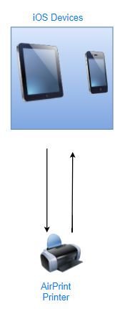

*Figure 1: Hardware Architecture - Offline Version*

### 3.1.2 ONLINE VERSION

The online application consists of two hardware components: the iOS iPhone or iPad, and an AirPrint enabled printer. It requires a WIFI connection to connect to an AirPrint enabled printer. This application requires 570 MB of space in the user’s iOS device. Below is the visualization of the hardware architecture.



*Figure 2: Hardware Architecture - Online Version*

## 3.2 SOFTWARE ARCHITECTURE

MyHealthKeeper will be designed to work for iOS devices running on iOS version 10.0 and above. The user must have a valid Apple ID and password to download the application from the App Store. In addition, the server application should also be able to send and retrieve data from the AWS server.

### 3.3.1 SOFTWARE ARCHITECTURE- OFFLINE APPLICATION

The offline application follows the MVC (Model-View-Controller) architecture. It consists of three layers: a frontend UI layer, backend(model) data storage layer, and controller layer, which acts as the intermediary mediator layer between the frontend UI and backend database. Our application will use the following software components: iOS operating system version 10.0 and above and an encrypted SQLite database with an FMDB wrapper. The database is encrypted using an open source API called SQLcipher. The version of SQLite integrated in the application 3.20.1, the version of SQLcipher integrated into our application is 3.4.0, and the version of FMDB integrated in the application is 2.7.

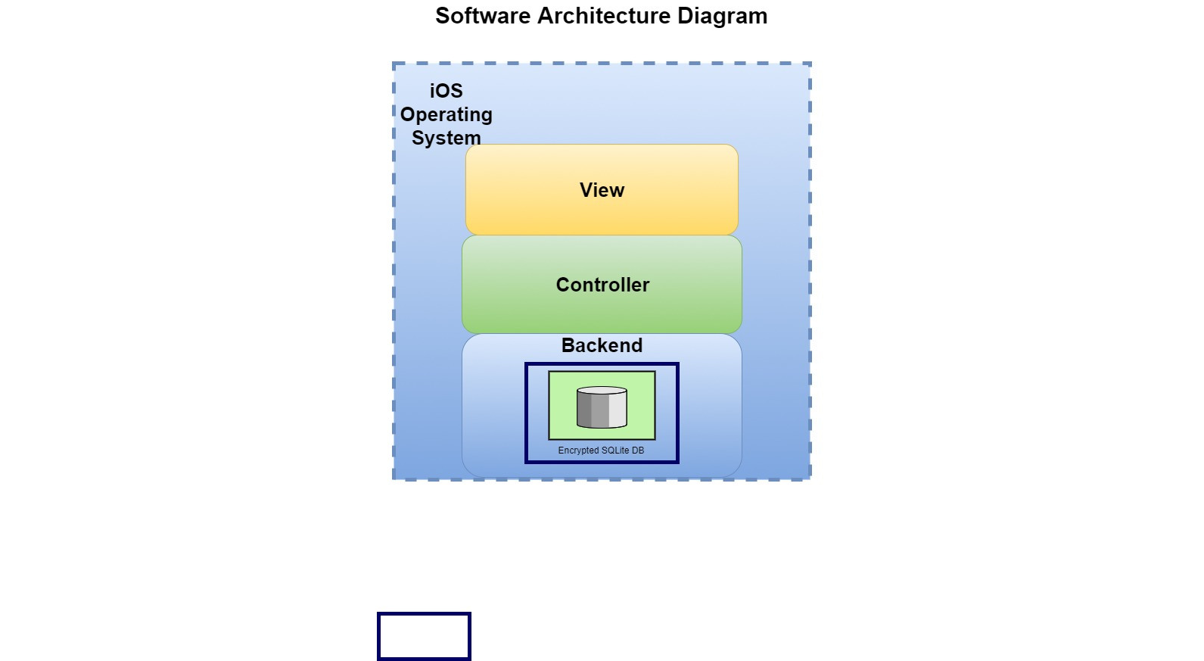

*Figure 3: Software Architecture Diagram - Offline Version*

### 3.3.2 SOFTWARE ARCHITECTURE- ONLINE APPLICATION

The online application follows the MVC (Model-View-Controller) architecture. It consists of three layers: a frontend UI layer, backend (model) data storage layer, and controller layer, which acts as the intermediary mediator layer between the frontend UI and backend database. Our application will use the following software components: iOS operating system version 10.0 and above, encrypted SQLite database with an FMDB wrapper, and MySQL database on a Linux AMI EC2 instance hosted by Amazon Web Service. The database is encrypted using an open source API called SQLcipher. The version of SQLite integrated in the application 3.20.1, the version of SQLcipher integrated into our application is 3.4.0, and the version of FMDB integrated in the application is 2.7.



*Figure 4: Software Architecture Diagram - Online Version*

## 3.3 SECURITY ARCHITECTURE

Any registered user with an iOS device can access MyHealthKeeper.

### 3.3.1 SECURITY ARCHITECTURE- OFFLINE APPLICATION

Data on the iOS device will be stored in an embedded database called SQLite. This ensures that the device is not connected to a server or external database, and the data remains secure on the device. Also, data going to the database for storage will be encrypted. This is to ensure that if an outside user gains access to the database, they will not be able to read a user’s stored information. For further data protection, only registered users can access MyHealthKeeper. This will be done by providing a valid username, password, and security questions and answers associated with a registered account.

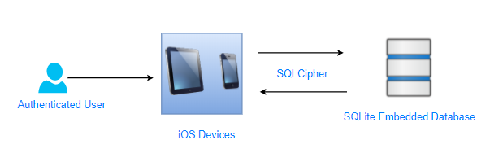

*Figure 5: Security Architecture Diagram - Offline Version*

### 3.3.2 SECURITY ARCHITECTURE- ONLINE APPLICATION

Data on the iOS device sent to the server will be using the HTTPS transfer protocol to ensure that the data remains secure. For further data security, only registered users can access the Health App. This will be done by providing a valid username, password, and security questions and answers associated with a registered account. If a user decides to share their data, they can do so by sending their medical information PDF to another iOS device via AirDrop. A firewall is formed around the connection, and the files are encrypted as they are sent to an iOS device.

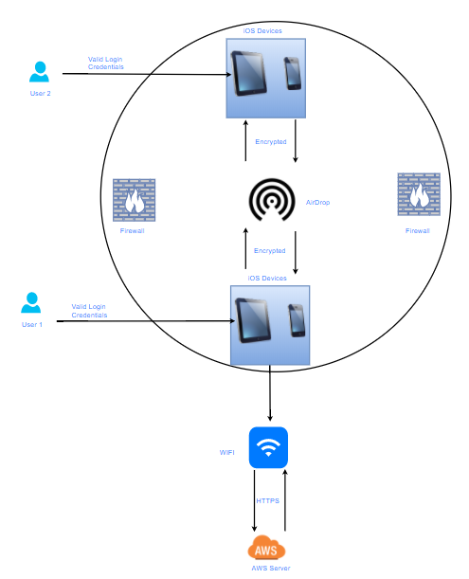

*Figure 6: Security Architecture Diagram - Online Version*

## 3.4 COMMUNICATION ARCHITECTURE

The offline version of the application will interact with a SQLite database where the data will be stored locally and securely on the user’s device.

The online version of the application will communicate with a server and database hosted on Amazon Web Services. Data that is sent to the server will be protected using the HTTPS transfer protocol. The online version of the application will also utilize AirDrop for the ‘Share’ feature.

MyHealthKeeper will connect to the user’s camera and photo library/gallery, requires a WIFI connection to connect to an AirPrint enabled printer, and send reminders to the iOS device in the form of notifications to users.

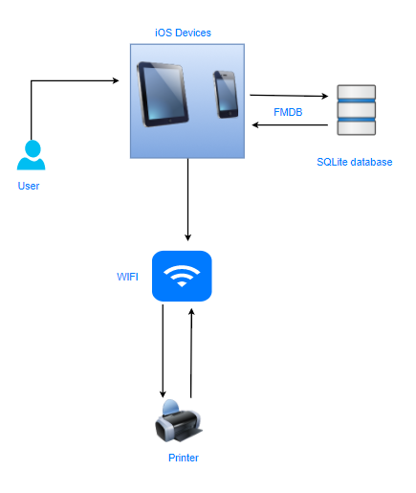

*Figure 7: Communication Architecture - Offline Version*

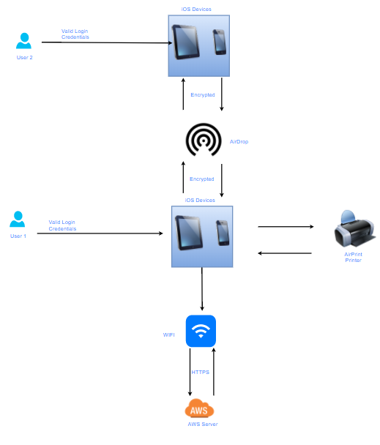

*Figure 8: Communication Architecture - Online Version*

# 4. SYSTEM DESIGN

## 4.1 USE-CASES

|  |  |
| --- | --- |
| **Use Case ID:** | UC - 1 |
| **Use Case Name:** | User Registration |
| **Actors:** | New User |
| **Description:** | New User registers and creates an account for the first time |
| **Trigger:** | Successful entry of first name, last name, username, password, and email/cellphone when New User taps ‘Next Page’ |
| **Preconditions:** | 1. New user is on Sign In page of MyHealthKeeper application 2. New User taps ‘Click to Register’ button on MyHealthKeeper application |
| **Postconditions:** | Registered User’s information is saved in the database, and is directed to the ‘Setup Security Questions’ page |
| **Normal Flow:** | 1. New User enters First name in designated text field 2. New User enters Fast name in designated text field 3. New User enters Username in designated text field 4. New User enters Password in designated text field 5. New User enters Email in designated text field 6. New User taps ‘Next Page’ 7. Registered User’s information is saved in the database 8. Registered User is directed to the ‘Setup Security Questions’ page |
| **Alternative Flows:** | 5. New User enters Cellphone in designated text field  6. New User clicks ‘Next Page’  7. Registered User’s information is saved in the database  8. Registered User is directed to the ‘Setup Security Questions’ page |
| **Frequency of Use:** | 5% |
| **Assumptions:** | 1. Active internet connection to download MyHealthKeeper iOS application 2. MyHealthKeeper App is downloaded on an iOS device 3. New User has opened the MyHealthKeeper application |

|  |  |
| --- | --- |
| **Use Case ID:** | UC - 2 |
| **Use Case Name:** | Setup Security Questions |
| **Actors:** | Registered User |
| **Description:** | New User selects and answers three Security Questions after Registration |
| **Trigger:** | Successful selection of three Security Questions and entry of three Security Answers when Registered User taps ‘Submit’ button |
| **Preconditions:** | 1. User has tapped “Next Page” button on registration page 2. User is directed to Set Up Security Question page |
| **Postconditions:** | Registered User’s Security Questions and Answers are saved to the database, and is directed to the Main page |
| **Normal Flow:** | 1. New User selects first Security Question using a picker 2. New User enters first Security Answer in designated text field 3. New User selects second Security Question using a picker 4. New User enters second Security Answer in designated text field 5. New User selects third Security Question using a picker 6. New User enters third Security Answer in designated text field 7. New User taps ‘Finish and Sign In’ button |
| **Alternative Flows:** | 1. New User selects Security Question 1 using the Picker 2. New User selects Security Question 2 using the Picker 3. New User selects Security Question 3 using the Picker 4. New User enters answer to first question in the designated field 5. New User enters answer to second question in the designated field 6. New User enters answer to third question in the designated field 7. New User taps ‘Finish and Sign In’ button |
| **Frequency of Use:** | 5% |
| **Assumptions:** | 1. Active internet connection to download myHealthKeeper iOS application 2. MyHealthKeeper App is already downloaded on an iOS device 3. User has opened the MyHealthKeeper application 4. User has successfully registered |

|  |  |
| --- | --- |
| **Use Case ID:** | UC - 3 |
| **Use Case Name:** | User Login |
| **Actors:** | Registered User |
| **Description:** | Registered User enters username and password |
| **Trigger:** | Successful entry of username and password when Registered User taps ‘Sign In’ button |
| **Preconditions:** | 1. User has successfully registered and successfully completed setting up Security Questions |
| **Postconditions:** | 1. Executed query successfully compares text field inputs to data saved in the database 2. Registered User is directed to the Main page |
| **Normal Flow:** | 1. Registered User enters username in designated text field 2. Registered User enters password in designated text field 3. Registered User taps ‘Sign In’ button |
| **Alternative Flows:** | None |
| **Frequency of Use:** | 100% |
| **Assumptions:** | 1. Active internet connection to download MyHealthKeeper App iOS application 2. MyHealthKeeper App is already downloaded on an iOS device 3. Registered User has opened the MyHealthKeeper application |

|  |  |
| --- | --- |
| **Use Case ID:** | UC - 4 |
| **Use Case Name:** | Forgot Password |
| **Actors:** | Registered User |
| **Description:** | Registered User forgets their password and resets it by answering their Security Questions they selected after Registration |
| **Trigger:** | Successful entry of Security Answers when Registered User taps ‘Submit’ button |
| **Preconditions:** | 1. The Registered User enters their username in the designated text field and taps ‘Forgot Password’ |
| **Postconditions:** | 1. The database deletes the original password and updates the Security table with the new password 2. The Registered user is directed back to the Main page 3. The Registered user can sign in with their username and new password |
| **Normal Flow:** | 1. The database retrieves the three Security Questions the Registered User answered during Registration and displays them on the ‘Answer Security Questions’ page that the Registered User is directed to 2. The Registered User answers the three Security Questions that is displayed on the Answer Security Questions page 3. The Registered User taps ‘Submit’ button 4. The database compares the answers in the text fields to the answers in the database 5. If answers match the data stored in the database, the Registered User is directed to the ‘Reset Password’ page 6. The Registered User enters their new password in the ‘Enter New Password’ text field and confirms the new password in the ‘Confirm New Password’ text field. 7. The Registered User taps ‘Submit New Password’ button. |
| **Alternative Flows:** | None |
| **Frequency of Use:** | 10% |
| **Assumptions:** | 1. Active internet connection to download MyHealthKeeper App iOS application 2. MyHealthKeeper App is already downloaded on an iOS device 3. User has opened the MyHealthKeeper application 4. User has successfully registered and answered Security Questions 5. Registered User has valid login credentials |

|  |  |
| --- | --- |
| **Use Case ID:** | UC - 5 |
| **Use Case Name:** | Enter Personal Information |
| **Actors:** | Registered User |
| **Description:** | Registered User inputs their Personal Information |
| **Trigger:** | Successful entry of Personal Information data when user taps ‘Save and Continue’ button |
| **Preconditions:** | 1. Registered User taps ‘Enter Medical History’ button and is directed to that page |
| **Postconditions:** | 1. Registered User’s Personal Information data is saved to the database 2. Registered User is directed to the Doctor page |
| **Normal Flow:** | 1. Registered User enters last name into designated text field 2. Registered User enters first name into designated text field 3. Registered User enters date of birth into designated text field 4. Registered User enters gender into designated text field 5. Registered User enters street into designated text field 6. Registered User enters city into designated text field 7. Registered User enters state into designated text field using the Picker 8. Registered User enters zip code into designated text field 9. Registered User taps ‘Save and Continue’’ button |
| **Alternative Flows:** | None |
| **Frequency of Use:** | 25% |
| **Assumptions:** | 1. Active internet connection to download MyHealthKeeper App iOS application 2. MyHealthKeeper App is already downloaded on an iOS device 3. User has opened the MyHealthKeeper application 4. User has successfully registered and answered Security Questions 5. Registered User has valid login credentials 6. Registered User is on the Main page |

|  |  |
| --- | --- |
| **Use Case ID:** | UC - 6 |
| **Use Case Name:** | Enter List of Doctor(s) |
| **Actors:** | Registered User |
| **Description:** | Registered User inputs Doctor Information |
| **Trigger:** | Registered User successfully enters Doctor Information |
| **Preconditions:** | 1. Registered User taps ‘Save and Continue’’ button on Personal Information page |
| **Postconditions:** | Registered User is directed to the Illness page |
| **Normal Flow:** | 1. Registered User enters Doctor’s information that is listed below    1. Doctor’s Name into designated text field that is required    2. Doctor’s Specialty into designated text field that is optional    3. Doctor’s Contact Number into designated text field that is optional    4. Doctor’s Address into designated text field that is optional 2. Registered User taps ‘Add’ button 3. Doctor information that the user entered will be displayed on the same page below the text field(s) 4. Registered user can enter more than one Doctor’s information by repeating steps 1 - 2 5. Registered User’s list of Doctors is saved in the database 6. Registered User taps ‘Save and Continue’ button |
| **Alternative Flows:** | 1. Registered User taps ‘Menu’ button on the Main page 2. Registered User taps ‘Medical Data’’ button on Menu 3. Registered User taps ‘Doctor’ button on Menu 4. Registered User is directed to the ‘List of Doctors’ page 5. Registered User can enter and view doctor information by repeating steps 1 -3 from the Normal Flow 6. Registered User’s list of Doctors is saved in the database 7. Registered User taps ‘Save and Continue’ button |
| **Frequency of Use:** | 25% |
| **Assumptions:** | 1. Active internet connection to download MyHealthKeeper App iOS application 2. MyHealthKeeper App is already downloaded on an iOS device 3. User has opened the MyHealthKeeper application 4. User has successfully registered and answered Security Questions 5. Registered User has valid login credentials |

|  |  |
| --- | --- |
| **Use Case ID:** | UC - 7 |
| **Use Case Name:** | Enter List of Illnesses/Diseases |
| **Actors:** | Registered User |
| **Description:** | Registered User inputs Illness Information |
| **Trigger:** | Registered User successfully enters name of Illnesses/Disease |
| **Preconditions:** | 1. Registered User taps ‘Save and Continue’’ button on List of Doctor page |
| **Postconditions:** | Registered User is directed to the Medication page |
| **Normal Flow:** | 1. Registered User enters Illness/Disease into designed text field 2. Registered User taps ‘Add’ button 3. Entered Illness/Disease will be displayed on same page 4. Registered User can enter more than one Illness/Disease name by repeating steps 1 - 3 5. Registered User’s list of Illnesses/Disease is saved in the database 6. Registered User taps ‘Save and Continue’ button |
| **Alternative Flows:** | 1. Registered User taps ‘Menu’ button on the Main page 2. Registered User taps ‘Medical Data’’ button 3. Registered User taps ‘Illness’ button 4. Registered User is directed to the ‘List of Illnesses/Disease’ page 5. Registered User can enter more than one illness name by repeating steps 1 -3 from the Normal Flow 6. Registered User’s list of Illnesses/Diseases is saved in the database 7. Registered User taps ‘Save and Continue’ button |
| **Frequency of Use:** | 25% |
| **Assumptions:** | 1. Active internet connection to download MyHealthKeeper App iOS application 2. MyHealthKeeper App is already downloaded on an iOS device 3. User has opened the MyHealthKeeper application 4. User has successfully registered and answered Security Questions 5. Registered User has valid login credentials |

|  |  |
| --- | --- |
| **Use Case ID:** | UC - 8 |
| **Use Case Name:** | Enter Medication List |
| **Actors:** | Registered User |
| **Description:** | Registered User inputs list of medications, dosage, and status (Current/Past) |
| **Trigger:** | Registered User successfully enters name of medication, dosage, and status |
| **Preconditions:** | 1. Registered User taps ‘Save and Continue’’ button on List of Illnesses/Diseases page |
| **Postconditions:** | Registered User is directed to the Surgery page |
| **Normal Flow:** | 1. Registered User enters Medication name into text field 2. Registered User enters Medication dosage into text field 3. Registered User enters Medication status (current/past) into text field using a picker 4. Registered User taps ‘Add’ button 5. Entered Medication name, dosage, and status will be displayed on same page 6. Registered User can enter more than one Medication by repeating steps 1 - 5 7. Registered User’s list of Medication is saved in the database 8. Registered User taps ‘Save and Continue’' button |
| **Alternative Flows:** | 1. Registered User taps on ‘Menu’ tab on the Main page 2. Registered User taps on ‘Medical Data’ button 3. Registered User taps on ‘Medication’ button 4. Registered User is directed to the ‘List of Medication’ page 5. Registered user enters Medication name into text field 6. Registered User enters Medication dosage into text field 7. Registered User enters Medication status (current/past) into text field 8. Registered user taps ‘Add’ button 9. Entered Medication will be displayed on same page 10. Registered user can enter more than one Medication by repeating steps 5 - 9 11. Registered User’s list of Medications is saved in the database 12. Registered User taps ‘Save and Continue’ button |
| **Frequency of Use:** | 25% |
| **Assumptions:** | 1. Active internet connection to download MyHealthKeeper App iOS application 2. MyHealthKeeper App is already downloaded on an iOS device 3. User has opened the MyHealthKeeper application 4. User has successfully registered and answered Security Questions 5. Registered User has valid login credentials |

|  |  |
| --- | --- |
| **Use Case ID:** | UC - 9 |
| **Use Case Name:** | Enter List of Surgeries |
| **Actors:** | Registered User |
| **Description:** | Registered User inputs list of Surgeries |
| **Trigger:** | Registered User successfully enters the name of the surgery |
| **Preconditions:** | 1. Registered User taps ‘Save and Continue’’ button on List of Medication page |
| **Postconditions:** | Registered User is directed to the Allergies page |
| **Normal Flow:** | 1. Registered User enters Surgery information that is listed below    1. Surgery’s Name into designated text field that is required    2. Surgery’s Date into designated text field that is optional    3. Surgery’s Description into designated text field that is optional 2. Registered User taps ‘Add’ button 3. Entered Surgery information will be displayed on same page 4. Registered User can enter more than one Surgery information by repeating steps 1 - 3 5. Registered User’s list of Surgeries is saved in the database 6. Registered User taps ‘Save and Continue’ button |
| **Alternative Flows:** | 1. Registered User taps ‘Menu’ tab on the Main page 2. Registered User taps ‘Medical Data’ button 3. Registered User taps ‘Surgeries’ button 4. Registered User is directed to the ‘List of Surgeries’ page 5. Registered User can enter and view more than one surgery information by repeating steps 1 -3 from the Normal Flow 6. Registered User’s list of Surgeries is saved in the database 7. Registered User taps ‘Save and Continue’ button |
| **Frequency of Use:** | 25% |
| **Assumptions:** | 1. Active internet connection to download MyHealthKeeper App iOS application 2. MyHealthKeeper App is already downloaded on an iOS device 3. User has opened the MyHealthKeeper application 4. User has successfully registered and answered Security Questions 5. Registered User has valid login credentials |

|  |  |
| --- | --- |
| **Use Case ID:** | UC - 10 |
| **Use Case Name:** | Enter List of Allergies |
| **Actors:** | Registered User |
| **Description:** | Registered User inputs list of Allergies |
| **Trigger:** | Registered User successfully enters name of Allergy |
| **Preconditions:** | 1. Registered User taps ‘Save and Continue’’ button on List of Surgeries page |
| **Postconditions:** | Registered User is directed to the Vaccines page |
| **Normal Flow:** | 1. Registered User enters Allergy information that is listed below    1. Allergy Name into designated text field that is required    2. Allergy Medication into designated text field that is optional    3. Allergy Treatment into designated text field that is optional 2. Registered User taps ‘Add’ button 3. Entered Allergy information will be displayed on same page 4. Registered User can enter more than one Allergy by repeating steps 1 - 3 5. Registered User’s list of Allergies is saved in the database 6. Registered User taps ‘Save and Continue’ button |
| **Alternative Flows:** | 1. Registered User taps ‘Menu’ tab on the Main page 2. Registered User taps ‘Medical Data’ button 3. Registered User taps ‘Allergies’ button 4. Registered User can enter and view more than one Allergy information by repeating steps 1 -3 from the Normal Flow 5. Registered User’s list of Allergies is saved in the database 6. Registered User taps ‘Continue to Add Vaccine’ button |
| **Frequency of Use:** | 25% |
| **Assumptions:** | 1. Active internet connection to download MyHealthKeeper App iOS application 2. MyHealthKeeper App is already downloaded on an iOS device 3. User has opened the MyHealthKeeper application 4. User has successfully registered and answered Security Questions 5. Registered User has valid login credentials |

|  |  |
| --- | --- |
| **Use Case ID:** | UC - 11 |
| **Use Case Name:** | Enter List of Vaccines |
| **Actors:** | Registered User |
| **Description:** | Registered User inputs list of vaccines |
| **Trigger:** | Registered User successfully enters name of vaccine |
| **Preconditions:** | 1. Registered User taps ‘Save and Continue’’ button on List of Allergies page |
| **Postconditions:** | Registered User is directed to the Family History and Notes page |
| **Normal Flow:** | 1. Registered User enters Vaccine information that is listed below    1. Vaccine Name into designated text field that is required    2. Vaccine Date into designated text field that is optional 2. Registered User taps ‘Add’ button 3. Entered Vaccine information will be displayed on same page 4. Registered User can enter more than one Vaccine by repeating steps 1 - 3 5. Registered User’s list of Vaccines is saved in the database 6. Registered User taps on ‘Save and Continue’ button |
| **Alternative Flows:** | 1. Registered User taps ‘Menu’ tab on the Main page 2. Registered User taps ‘Medical Data’ button 3. Registered User taps ‘Vaccines’ button 4. Registered User is directed to the ‘List of Vaccine’ page 5. Registered User can enter and view more than one Vaccine information by repeating steps 1 - 3 from the Normal Flow 6. Registered User’s list of Vaccines is saved in the database 7. Registered User taps ‘Save and Continue’ button |
| **Frequency of Use:** | 25% |
| **Assumptions:** | 1. Active internet connection to download MyHealthKeeper App iOS application 2. MyHealthKeeper App is already downloaded on an iOS device 3. User has opened the MyHealthKeeper application 4. User has successfully registered and answered Security Questions 5. Registered User has valid login credentials |

|  |  |
| --- | --- |
| **Use Case ID:** | UC - 12 |
| **Use Case Name:** | Enter Family Medical History and Note |
| **Actors:** | Registered User |
| **Description:** | Registered User inputs Family Medical History and any additional Notes |
| **Trigger:** | Registered User successfully enters Family Medical History and any additional Notes |
| **Preconditions:** | 1. Registered User taps ‘Save and Continue’’ button on List of Vaccines page |
| **Postconditions:** | Registered User is directed to the Insurance page |
| **Normal Flow:** | 1. Registered User enters Family History into designated text View 2. Registered User enters Note into designated text View 3. Entered Family History and Notes will be displayed on same page 4. Registered User taps ‘Save and Continue’ button 5. Registered User’s Family History and Notes are saved in the database |
| **Alternative Flows:** | 1. Registered User taps ‘Menu’ tab on Main page 2. Registered User taps ‘Medical Data’ button 3. Registered User taps ‘Additional’ button 4. Registered User is directed to the ‘Medical History’ page 5. Registered User enters Family History into designated text view 6. Registered User enters Note into designated text view 7. Entered Family History and Notes will be displayed on same page 8. Registered User taps ‘Save and Continue’ button 9. Registered User’s Family History and Notes are saved in the database |
| **Frequency of Use:** | 25% |
| **Assumptions:** | 1. Active internet connection to download MyHealthKeeper App iOS application 2. MyHealthKeeper App is already downloaded on an iOS device 3. User has opened the MyHealthKeeper application 4. User has successfully registered and answered Security Questions 5. Registered User has valid login credentials |

|  |  |
| --- | --- |
| **Use Case ID:** | UC - 13 |
| **Use Case Name:** | Enter Insurance Information |
| **Actors:** | Registered User |
| **Description:** | User inputs Insurance Information |
| **Trigger:** | User successfully enters Insurance Information |
| **Preconditions:** | 1. Registered User taps ‘Save and Continue’’ button on Family History and Notes page |
| **Postconditions:** | Registered User is directed to the Medical Summary page if user taps on ‘No’ on the alert or Registered User is directed to Document Upload page if user taps on ‘Yes’ on the alert |
| **Normal Flow:** | 1. Registered User enters Type of Insurance designated into text field 2. Registered User enters Name of Insurance into designated text field 3. Registered User enters Group ID into designated text field 4. Registered User enters Expiration Date designated into text field 5. Registered User’s Insurance Information is displayed on the same page 6. Registered User taps the ‘Finish’ button 7. Registered User’s Insurance Information is saved in the database 8. Registered User is prompted with an alert to decide whether or not they want to upload a document |
| **Alternative Flows:** | 1. Registered User can tap on ‘Menu’ tab on the Main page 2. Registered User taps on ‘Medical Data’ button 3. Registered User taps on ‘Insurance Information’ button 4. Registered User is directed to the ‘Insurance Information’ page 5. Registered User enters Type of Insurance into text field 6. Registered User enters Name of Insurance into text field 7. Registered User enters Group Id into text field 8. Registered User enters Expiration Date into text field 9. Registered User’s Insurance Information is displayed on the same page 10. Registered User taps the ‘Finish’ button 11. Registered User’s Insurance Information is saved in the database 12. Registered User is prompted with an alert to decide whether or not they want to upload a document |
| **Frequency of Use:** | 25% |
| **Assumptions:** | 1. Active internet connection to download MyHealthKeeper App iOS application 2. MyHealthKeeper App is already downloaded on an iOS device 3. User has opened the MyHealthKeeper application 4. User has successfully registered and answered Security Questions 5. Registered User has valid login credentials |

|  |  |
| --- | --- |
| **Use Case ID:** | UC - 14 |
| **Use Case Name:** | View Medical History |
| **Actors:** | Registered User |
| **Description:** | Registered User views all Medical Information that is saved |
| **Trigger:** | Registered User is on the Medical History Summary page |
| **Preconditions:** | 1. Registered User has successfully logged into the MyHealthKeeper Application |
| **Postconditions:** | All Medical Information including Personal Information, List of Doctors, Illnesses/Diseases, Medication, Surgeries, Allergies, Vaccine, Insurance Information, and Family Medical History is displayed. |
| **Normal Flow:** | 1. Registered User taps the ‘Finish’ button on Insurance Information page 2. Registered User’s Insurance Information is saved in the database 3. An alert appears asking if the Registered User wants to Upload a Document 4. Registered User taps ‘No’ 5. Registered User is directed to the Medical History Summary page |
| **Alternative Flows:** | 1. Registered User is on the Main Page 2. Registered User taps ‘Menu’ to display menu options 3. Registered User taps ‘View Medical’ in the Menu 4. Registered User is directed to the ‘Medical Summary’ page |
| **Frequency of Use:** | 25% |
| **Assumptions:** | 1. Active internet connection to download MyHealthKeeper App iOS application 2. MyHealthKeeper App is already downloaded on an iOS device 3. User has opened the MyHealthKeeper application 4. User has successfully registered and answered Security Questions 5. Registered User has valid login credentials |

|  |  |
| --- | --- |
| **Use Case ID:** | UC - 15 |
| **Use Case Name:** | Delete Doctor(s) |
| **Actors:** | Registered User |
| **Description:** | Registered User deletes doctor(s) information |
| **Trigger:** | Registered User successfully deleted doctor(s) information |
| **Preconditions:** | 1. Registered User is on the ‘Enter List of Doctor’ page for Normal Flow or the main page for Alternative flow 2. Registered User already entered at least one doctor information to the list of doctors on the ‘Enter List of Doctors’ page |
| **Postconditions:** | 1. Doctor name is removed from the list and database |
| **Normal Flow:** | 1. Registered User taps on ‘Edit’ button 2. On the left side of the doctor name cell that the Registered User wishes to delete, the user taps on the red icon 3. On the right side of the doctor name cell that the Registered User wishes to delete, the user taps on the ‘Delete’ button 4. Doctor’s information is removed from list of doctors 5. Doctor’s information is removed from the database 6. Registered User can delete more than one doctor name by repeating steps 1-3 |
| **Alternative Flows:** | 1. Registered User taps on the ‘Menu’ tab on the Main page 2. Registered User taps on the ‘Medical Data’ button 3. Registered User taps on the ‘Doctor’ button 4. Registered User taps on ‘Edit’ button 5. On the left side of the doctor name cell that the Registered User wishes to delete, the user taps on the red icon 6. On the right side of the doctor name cell that the Registered User wishes to delete, the user taps on the ‘Delete’ button 7. Doctor’s information is removed from list of doctors 8. Doctor’s information is removed from the database 9. Registered User can delete more than one doctor name by repeating steps 3-5 |
| **Frequency of Use:** | 25% |
| **Assumptions:** | 1. Active internet connection to download MyHealthKeeper App iOS application 2. MyHealthKeeper App is already downloaded on an iOS device 3. User has opened the MyHealthKeeper application 4. User has successfully registered and answered Security Questions 5. Registered User has valid login credentials |

|  |  |
| --- | --- |
| **Use Case ID:** | UC - 16 |
| **Use Case Name:** | Delete Illnesses/Disease(s) |
| **Actors:** | Registered User |
| **Description:** | Registered User deletes illnesses/disease(s) information |
| **Trigger:** | Registered User successfully deletes illnesses/disease(s) information |
| **Preconditions:** | 1. Registered User is on the ‘Enter List of Illnesses/Diseases’ page for Normal Flow or the main page for Alternative flow 2. Registered User already entered at least one illness/disease name to the list of illness/disease on the ‘Enter List of Illnesses/Disease’ page |
| **Postconditions:** | Illness/Disease name is removed from the list and database |
| **Normal Flow:** | 1. Registered User taps on ‘Edit’ button 2. On the left side of the Illness/Disease name cell that the Registered User wishes to delete, the user taps on the red icon 3. On the right side of the Illness/Disease name cell that the Registered User wishes to delete, the user taps on the ‘Delete’ button 4. Illness/Disease name is removed from list of Illness/Disease 5. Illness/Disease name is removed from the database 6. Registered User can delete more than one Illness/Disease name by repeating steps 1-3 7. Registered User’s updated list of Illness/Disease is saved in the database |
| **Alternative Flows:** | 1. Registered User taps the ‘Menu’ tab on the Main page 2. Registered User taps the ‘Medical Data’ button 3. Registered User taps the ‘Illness/Disease’ button 4. Registered User taps on ‘Edit’ button 5. On the left side of the Illness/Disease name cell that the Registered User wishes to delete, the user taps on the red icon 6. On the right side of the Illness/Disease name cell that the Registered Use 7. Illness/diseases name is removed from list of illness/disease 8. Illness/diseases name is removed from the database 9. Registered User can delete more than one illness/disease name by repeating steps 4-6 10. Registered User’s updated list of Illness/Disease is saved in the database |
| **Frequency of Use:** | 25% |
| **Assumptions:** | 1. Active internet connection to download MyHealthKeeper App iOS application 2. MyHealthKeeper App is already downloaded on an iOS device 3. User has opened the MyHealthKeeper application 4. User has successfully registered and answered Security Questions 5. Registered User has valid login credentials |

|  |  |
| --- | --- |
| **Use Case ID:** | UC - 17 |
| **Use Case Name:** | Delete Medication(s) |
| **Actors:** | Registered User |
| **Description:** | Registered User deletes medication(s) information |
| **Trigger:** | Registered User successfully deletes medication(s) information |
| **Preconditions:** | 1. Registered User is on the ‘Enter List of Medication’ page for Normal Flow or the main page for Alternative flow 2. Registered User already entered at least one medication name to the list of medications on the ‘Enter List of Medication’ page |
| **Postconditions:** | Medication name is removed from the list and database |
| **Normal Flow:** | 1. Registered User taps on ‘Edit’ button 2. On the left side of the medication name cell that the Registered User wishes to delete, the user taps on the red icon 3. On the right side of the medication name cell that the Registered User wishes to delete, the user taps on the ‘Delete’ button 4. Medication’s name is removed from list of medications 5. Medication’s name is removed from the database 6. Registered User can delete more than one medication name by repeating steps 1-3 7. Registered User’s updated list of medication is saved in the database |
| **Alternative Flows:** | 1. Registered User taps ‘Menu’ tab on the Main page 2. Registered User taps ‘Medical Data’ button 3. Registered User taps ‘Medication’ button 4. Registered User taps on ‘Edit’ button 5. On the left side of the medication name cell that the Registered User wishes to delete, the user taps on the red icon 6. On the right side of the medication name cell that the Registered User wishes to delete, the user taps on the ‘Delete’ button 7. Medication’s name is removed from list of medication 8. Medication’s name is removed from the database 9. Registered User can delete more than one medication name by repeating steps 4-6 10. Registered User’s updated list of medication is saved in the database |
| **Frequency of Use:** | 25% |
| **Assumptions:** | 1. Active internet connection to download MyHealthKeeper App iOS application 2. MyHealthKeeper App is already downloaded on an iOS device 3. User has opened the MyHealthKeeper application 4. User has successfully registered and answered Security Questions 5. Registered User has valid login credentials |

|  |  |
| --- | --- |
| **Use Case ID:** | UC - 18 |
| **Use Case Name:** | Delete Surgery |
| **Actors:** | Registered User |
| **Description:** | Registered User deletes surgery information |
| **Trigger:** | Registered User successfully deletes surgery information |
| **Preconditions:** | 1. Registered User is on the ‘Enter List of Surgeries’ page for Normal Flow or the main page for Alternative flow 2. Registered User already entered at least one surgery name to the list of surgeries on the ‘Enter List of Surgeries’ page |
| **Postconditions:** | Surgery name is removed from the list and database |
| **Normal Flow:** | 1. Registered User taps on ‘Edit’ button 2. On the left side of the Surgery name cell that the Registered User wishes to delete, the user taps on the red icon 3. On the right side of the medication name cell that the Registered User wishes to delete, the user taps on the ‘Delete’ button 4. Surgery’s name is removed from list of surgeries 5. Surgery’s name is removed from the database 6. Registered User can delete more than one surgeries name by repeating steps 1-3 7. Registered User’s updated list of Surgeries is saved in the database |
| **Alternative Flows:** | 1. Registered User taps ‘Menu’ tab on the Main page 2. Registered User taps ‘Medical Data’ button 3. Registered User taps ‘Surgery’ button 4. Registered User taps on ‘Edit’ button 5. On the left side of the Surgery name cell that the Registered User wishes to delete, the user taps on the red icon 6. On the right side of the medication name cell that the Registered User wishes to delete, the user taps on the ‘Delete’ button 7. Surgery’s name is removed from list of surgeries 8. Surgery’s name is removed from the database 9. Registered User can delete more than one surgeries name by repeating steps 4-6 10. Registered User’s updated list of Surgeries is saved in the database |
| **Frequency of Use:** | 25% |
| **Assumptions:** | 1. Active internet connection to download MyHealthKeeper App iOS application 2. MyHealthKeeper App is already downloaded on an iOS device 3. User has opened the MyHealthKeeper application 4. User has successfully registered and answered Security Questions 5. Registered User has valid login credentials |

|  |  |
| --- | --- |
| **Use Case ID:** | UC - 19 |
| **Use Case Name:** | Delete Allergies |
| **Actors:** | Registered User |
| **Description:** | Registered User deletes allergy information |
| **Trigger:** | Registered User successfully deletes allergy information |
| **Preconditions:** | 1. Registered User is on the ‘Enter List of Allergies’ page for Normal Flow or the main page for Alternative flow 2. Registered User already entered at least one allergy name to the list of doctors on the ‘Enter List of Allergies’ page |
| **Postconditions:** | Allergy name is removed from the list and database |
| **Normal Flow:** | 1. Registered User taps on ‘Edit’ button 2. On the left side of the Allergy name cell that the Registered User wishes to delete, the user taps on the red icon 3. On the right side of the allergy name cell that the Registered User wishes to delete, the user taps on the ‘Delete’ button 4. Allergy name is removed from list of allergies 5. Allergy name is removed from the database 6. Registered User can delete more than one allergy name by repeating steps 1-3 7. Registered User’s updated list of allergies is saved in the database |
| **Alternative Flows:** | 1. Registered User taps ‘Menu’ tab on the Main page 2. Registered User taps ‘Medical Data’ button 3. Registered User taps ‘Allergy’ button 4. Registered User taps on ‘Edit’ button 5. On the left side of the Allergy name cell that the Registered User wishes to delete, the user taps on the red icon 6. On the right side of the allergy name cell that the Registered User wishes to delete, the user taps on the ‘Delete’ button 7. Allergy name is removed from list of allergies 8. Allergy name is removed from the database 9. Registered User can delete more than one allergy name by repeating steps 4-6 10. Registered User’s updated list of allergies is saved in the database |
| **Frequency of Use:** | 25% |
| **Assumptions:** | 1. Active internet connection to download MyHealthKeeper App iOS application 2. MyHealthKeeper App is already downloaded on an iOS device 3. User has opened the MyHealthKeeper application 4. User has successfully registered and answered Security Questions 5. Registered User has valid login credentials |

|  |  |
| --- | --- |
| **Use Case ID:** | UC - 20 |
| **Use Case Name:** | Delete Vaccine(s) |
| **Actors:** | Registered User |
| **Description:** | Registered User deletes vaccine(s) information |
| **Trigger:** | Registered User successfully deletes vaccine(s) information |
| **Preconditions:** | 1. Registered User is on the ‘Enter List of Vaccine’ page for Normal Flow or the main page for Alternative flow 2. Registered User already entered at least one vaccine name to the list of vaccines on the ‘Enter List of Vaccine’ page |
| **Postconditions:** | Vaccine name is removed from the list and database |
| **Normal Flow:** | 1. Registered User taps on ‘Edit’ button 2. On the left side of the Vaccine name cell that the Registered User wishes to delete, the user taps on the red icon 3. On the right side of the Vaccine name cell that the Registered User wishes to delete, the user taps on the ‘Delete’ button 4. Vaccine’s name is removed from list of vaccine 5. Vaccine’s name is removed from the database 6. Registered User can delete more than one vaccine name by repeating steps 1-3 7. Registered User’s updated list of vaccine is saved in the database |
| **Alternative Flows:** | 1. Registered User taps ‘Menu’ tab on the Main page 2. Registered User taps ‘Medical Data’ button 3. Registered User taps ‘Vaccine’ button 4. Registered User taps on ‘Edit’ button 5. On the left side of the Vaccine name cell that the Registered User wishes to delete, the user taps on the red icon 6. On the right side of the Vaccine name cell that the Registered User wishes to delete, the user taps on the ‘Delete’ button 7. Vaccine’s name is removed from list of vaccine 8. Vaccine’s name is removed from the database 9. Registered User can delete more than one vaccine name by repeating steps 4-6 10. Registered User’s updated list of vaccine is saved in the database |
| **Frequency of Use:** | 25% |
| **Assumptions:** | 1. Active internet connection to download MyHealthKeeper App iOS application 2. MyHealthKeeper App is already downloaded on an iOS device 3. User has opened the MyHealthKeeper application 4. User has successfully registered and answered Security Questions 5. Registered User has valid login credentials |

|  |  |
| --- | --- |
| **Use Case ID:** | UC - 21 |
| **Use Case Name:** | Edit Doctor(s) Information |
| **Actors:** | Registered User |
| **Description:** | Registered User edits Doctor(s) Information |
| **Trigger:** | Registered User successfully edits Doctor(s) Information |
| **Preconditions:** | 1. Registered User is on the ‘Enter List of Doctor’ page for Normal Flow or the Main page for Alternative flow 2. Registered User already entered at least one Doctor’s Information to the List of Doctors on the ‘Enter List of Doctors’ page |
| **Postconditions:** | 1. Doctor information is Edit/Update in the List and database |
| **Normal Flow:** | 1. Registered User taps on ‘Edit’ button 2. On the left side of the doctor name cell that the Registered User wishes to edit, the user taps on the red icon 3. On the right side of the doctor name cell that the Registered User wishes to edit, the user taps on the ‘Edit’ button 4. Registered User is directed to Edit List of Doctors page 5. Registered user edits Doctor information they wish to edit such as Doctor name, Specialty, Contact or Address 6. Registered User taps on ‘Update’ button 7. An alert appears with Edit Status 8. Registered User taps on View Updated Information 9. Updated Doctor information is listed on Enter List of Doctors page |
| **Alternative Flows:** | 1. Registered User taps on ‘Menu’ button on the Main page 2. Registered User taps on ‘Medical Data’ button 3. Registered User taps on ‘Doctor’ button 4. Registered User is directed to List of Doctors page 5. Registered User follows steps 1 - 8 from normal flow |
| **Frequency of Use:** | 25% |
| **Assumptions:** | 1. Active internet connection to download MyHealthKeeper App iOS application 2. MyHealthKeeper App is already downloaded on an iOS device 3. User has opened the MyHealthKeeper application 4. User has successfully registered and answered Security Questions 5. Registered User has valid login credentials |

|  |  |
| --- | --- |
| **Use Case ID:** | UC - 22 |
| **Use Case Name:** | Upload Document through Camera |
| **Actors:** | Registered User |
| **Description:** | Registered User uploads a document through the device’s camera |
| **Trigger:** | User takes a picture from the device’s camera |
| **Preconditions:** | 1. Registered User taps ‘Upload Document’ button to navigate to the ‘Upload Document’ page or taps ‘Upload Document’ button through the menu |
| **Postconditions:** | 1. An alert appears for user to enter Document Name and Description. |
| **Normal Flow:** | 1. Registered User taps ‘Camera’ button on ‘Upload Document’ page 2. Camera displays with options to take picture or to cancel. 3. Registered User taps button to capture image 4. Registered User taps ‘Use Photo’ button 5. Registered User is navigated back to ‘Upload Document’ page and the image is displayed. 6. Registered User taps ‘Save’ button |
| **Alternative Flows:** | 1. User taps ‘Camera’ button on ‘Upload Document’ page 2. Error message displays stating “Camera is not available.” |
| **Frequency of Use:** | 20% |
| **Assumptions:** | 1. Active internet connection to download MyHealthKeeper App iOS application 2. MyHealthKeeper App is already downloaded on an iOS device 3. User has opened the MyHealthKeeper application 4. User has successfully registered and answered Security Questions 5. Registered User’s device has a camera and user provided permission for app to access the camera |

|  |  |
| --- | --- |
| **Use Case ID:** | UC - 23 |
| **Use Case Name:** | Upload Document through Photo Gallery |
| **Actors:** | Registered User |
| **Description:** | Registered User uploads a document through the device’s photo library |
| **Trigger:** | Registered User taps image in the Photo Library |
| **Preconditions:** | 1. Registered User taps ‘Upload Document’ button to navigate to the ‘Upload Document’ page or taps on ‘Upload Document’ through the menu |
| **Postconditions:** | 1. An alert appears for user to enter Document Name and Description. |
| **Normal Flow:** | 1. Registered User taps ‘Photo Library’ button 2. Pictures in the Photo Library are displayed 3. Registered User selects image by tapping on it 4. Pictures in the Photo Library slides down and disappears from the screen 5. Image is displayed on the page 6. Registered User taps ‘Save’ |
| **Alternative Flows:** | 1. Registered User taps ‘Photo Library’ button 2. Error message displays stating “Photo Library is not available.” |
| **Frequency of Use:** | 20% |
| **Assumptions:** | 1. Active internet connection to download MyHealthKeeper App iOS application 2. MyHealthKeeper App is already downloaded on an iOS device 3. User has opened the MyHealthKeeper application 4. User has successfully registered and answered Security Questions 5. Registered User’s device has images stored in the photo library and user provided permission for app to access the photo library |

|  |  |
| --- | --- |
| **Use Case ID:** | UC - 24 |
| **Use Case Name:** | Provide document name |
| **Actors:** | Registered User |
| **Description:** | Registered User provides uploaded document a name and an optional description |
| **Trigger:** | Registered User taps ‘OK’ button |
| **Preconditions:** | 1. Registered User has uploaded a document through the Camera or Photo Library |
| **Postconditions:** | 1. Document Name, Description, and image path is saved to the database 2. Image is stored in the application’s default directory. 3. Registered User is directed to Document Summary page |
| **Normal Flow:** | 1. Registered User enters a name on the provided ‘Document Name’ text field in the alert. 2. Registered User enters a description on the provided ‘Document Description’ text field in the alert. 3. Registered User taps ‘OK’ button. |
| **Alternative Flows:** | 1. Registered User enters a name on the provided ‘Document Name’ text field in the alert. 2. Registered User taps ‘OK’ button. |
| **Frequency of Use:** | 25% |
| **Assumptions:** | 1. Active internet connection to download MyHealthKeeper App iOS application 2. MyHealthKeeper App is already downloaded on an iOS device 3. User has opened the MyHealthKeeper application 4. User has successfully registered and answered Security Questions |

|  |  |
| --- | --- |
| **Use Case ID:** | UC - 25 |
| **Use Case Name:** | View Uploaded Documents |
| **Actors:** | Registered User |
| **Description:** | Registered User views all the documents the user saved |
| **Trigger:** | Registered User is on the Uploaded Documents Summary Page |
| **Preconditions:** | 1. Registered User saved a document and its name |
| **Postconditions:** | 1. All documents and its corresponding names are displayed |
| **Normal Flow:** | 1. Registered User taps ‘OK’ button on the alert presented in Upload Documents page 2. Registered User is directed to the Documents Summary Page where the image and its corresponding name and/or description is displayed in the same cell. |
| **Alternative Flows:** | 1. Registered User is on the Main page 2. Registered User taps ‘Menu’ to open up options 3. Registered User taps ‘View Documents’ in the Menu 4. Registered User is directed to the Documents Summary Page where the image and its corresponding name and/or description is displayed in the same cell. |
| **Frequency of Use:** | 30% |
| **Assumptions:** | 1. Active internet connection to download MyHealthKeeper App iOS application 2. MyHealthKeeper App is already downloaded on an iOS device 3. User has opened the MyHealthKeeper application 4. User has successfully registered and answered Security Questions 5. Registered User has uploaded an image from the camera or photo library and a name for each image |

|  |  |
| --- | --- |
| **Use Case ID:** | UC - 26 |
| **Use Case Name:** | Delete Documents |
| **Actors:** | Registered User |
| **Description:** | Registered User deletes documents the user does not want |
| **Trigger:** | Registered User taps ‘Delete’ button |
| **Preconditions:** | 1. Registered User is on the ‘Uploaded Documents’ summary page |
| **Postconditions:** | 1. The image and its corresponding name is removed from the summary page 2. The image and its corresponding name is deleted from the database |
| **Normal Flow:** | 1. Registered User taps ‘Delete’ button on the navigation bar 2. Registered User taps the red icon on the left side of the row that holds the image 3. Registered User taps the ‘Delete’ button on the right side of the row |
| **Alternative Flows:** | 1. Registered User slides a row that holds the image from right to left 2. Registered User taps on the ‘Delete’ button on the right side of the row |
| **Frequency of Use:** | 25% |
| **Assumptions:** | 1. Active internet connection to download MyHealthKeeper App iOS application 2. MyHealthKeeper App is already downloaded on an iOS device 3. User has opened the MyHealthKeeper application 4. User has successfully registered and answered Security Questions 5. User has saved an image from the camera or photo library and a name for each image |

|  |  |
| --- | --- |
| **Use Case ID:** | UC - 27 |
| **Use Case Name:** | Monthly Reminders to Update Medical History |
| **Actors:** | Notification Center, User’s Device |
| **Description:** | Registered User will automatically receive a notification on the first day of every month at 12 pm reminding the user to update their medical history |
| **Trigger:** | The time is 12pm on the first day of any given month |
| **Preconditions:** | 1. Registered User should have given the application permission to send notifications to their device 2. Registered User should have turned on monthly notifications in the app. |
| **Postconditions:** | The reminder notification will be sent to the Registered User’s iOS device on the first day of every month at 12pm. |
| **Normal Flow:** | 1. Notification will appear on the first day of every month at 12PM |
| **Alternative Flows:** | 1. Registered User disables notifications for the application 2. The notification will not appear on the first day of every month |
| **Frequency of Use:** | 3% |
| **Assumptions:** | 1. Active internet connection to download MyHealthKeeper App iOS application 2. MyHealthKeeper App is already downloaded on an iOS device 3. User has opened the MyHealthKeeper application 4. User has successfully registered and answered Security Questions 5. Registered User has valid login credentials |

|  |  |
| --- | --- |
| **Use Case ID:** | UC - 28 |
| **Use Case Name:** | Turn Monthly Reminders to Update Medical Information On |
| **Actors:** | Registered User |
| **Description:** | Registered User turns on the automatic monthly reminder feature. This reminds the Registered User, on the first day of every month, to update their medical information. |
| **Trigger:** | Registered User taps the ‘Monthly Reminder’ switch |
| **Preconditions:** | 1. The monthly reminder switch on the ‘Reminder’ page is turned off |
| **Postconditions:** | The Registered User will receive monthly reminders to update their medical information |
| **Normal Flow:** | 1. Registered User taps ‘Set Reminders’ button on the Main page 2. Registered User is directed to the ‘Reminders’ page 3. Registered User taps ‘Monthly Reminder’ switch 4. If the Registered User allowed the application to send notifications to their iOS device, monthly reminders are enabled 5. The Registered User will receive a reminder every month reminding them to update their medical information on the app |
| **Alternative Flows:** | 3. Registered User taps ‘Monthly Reminder’ switch  4. If the Registered User has not allowed the application to send notifications to their iOS device, they will be informed that they will not receive the reminder unless they enable notifications. |
| **Frequency of Use:** | 1% |
| **Assumptions:** | 1. Active internet connection to download MyHealthKeeper App iOS application 2. MyHealthKeeper App is already downloaded on an iOS device 3. User has opened the MyHealthKeeper application 4. User has successfully registered and answered Security Questions 5. Registered User has valid login credentials |

|  |  |
| --- | --- |
| **Use Case ID:** | UC - 29 |
| **Use Case Name:** | Turn Monthly Reminders to Update Medical Information Off |
| **Actors:** | Registered User |
| **Description:** | Registered User turns off automatic monthly reminders feature, which reminds them to update their medical information. |
| **Trigger:** | Registered User taps the ‘Monthly Reminder’ switch |
| **Preconditions:** | 1. The monthly medication reminder switch on the ‘Reminder’ page is turned on. |
| **Postconditions:** | The Registered User will not receive monthly reminders to update their medical information. |
| **Normal Flow:** | 1. Registered User taps ‘Set Reminders’ button on the Main page 2. Registered User is directed to the ‘Reminders’ page 3. Registered User taps ‘Monthly Reminder’ switch 4. Monthly reminders are disabled, and the Registered User will not receive a monthly reminder to update their medical information |
| **Alternative Flows:** | 1. Registered User taps ‘Set Reminders’ button on the Main page, which takes them to the ‘Reminders’ page 2. Registered User taps ‘Monthly Reminder’ switch 3. If the Registered User has not allowed the application to send notifications to their iOS device, they will be informed that they will not receive monthly reminders unless they allow the application to send notifications. |
| **Frequency of Use:** | 1% |
| **Assumptions:** | 1. Active internet connection to download MyHealthKeeper App iOS application 2. MyHealthKeeper App is already downloaded on an iOS device 3. User has opened the MyHealthKeeper application 4. User has successfully registered and answered Security Questions 5. Registered User has valid login credentials |

|  |  |
| --- | --- |
| **Use Case ID:** | UC - 30 |
| **Use Case Name:** | Add Appointment Reminders |
| **Actors:** | Registered User |
| **Description:** | Registered User adds an appointment reminder and will receive a notification before their appointment |
| **Trigger:** | Registered User taps ‘Submit’ button on the ‘Add Reminders’ page |
| **Preconditions:** | 1. Registered User should have given the application permission to send notifications to their iOS device |
| **Postconditions:** | The reminder will be added to the application’s database. The Registered User will receive a notification before their appointment. |
| **Normal Flow:** | 1. Registered User taps ‘Reminders’ button, which takes them to the ‘Reminders Page’ 2. Registered User enters Appointment Name in designated text field 3. Registered User enters Appointment Location in designated text field (optional step). 4. Registered User enters Appointment Reason in designated text field (optional step). 5. Registered User enters the date of their appointment in designated date picker. 6. Registered User taps the ‘Submit’ button. 7. A reminder is added to the database. 8. Registered User will receive a reminder notification on the date and time specified in the appointment. 9. Registered User receives a message that their appointment reminder was created successfully. |
| **Alternative Flows:** | 1. Registered User taps ‘Reminders’ button, which takes them to the ‘Reminders Page’. 2. Registered User doesn’t enter Appointment Name in designated text field. 3. Registered User enters Appointment Location (optional step) in designated text field. 4. Registered User enters Appointment Reason (optional step) in designated text field. 5. Registered User enters the date of their appointment in designated date picker. 6. Registered User taps ‘Submit’ button. 7. Registered User will receive an error message stating “Reminder Name field cannot be empty. Please enter a value.” |
| **Frequency of Use:** | 25% |
| **Assumptions:** | 1. Active internet connection to download MyHealthKeeper App iOS application. 2. MyHealthKeeper App is already downloaded on an iOS device. 3. User has opened the MyHealthKeeper application. 4. User has successfully registered and answered Security Questions. 5. Registered User has valid login credentials. |

|  |  |
| --- | --- |
| **Use Case ID:** | UC - 31 |
| **Use Case Name:** | View Appointment Reminders |
| **Actors:** | Registered User |
| **Description:** | Registered User will be able to view their appointment reminders |
| **Trigger:** | Registered User taps ‘View Reminders’ button on the Add Reminders page. |
| **Preconditions:** | 1. Registered User should have at least one appointment reminder stored in the database. 2. Registered User tapped on ‘Submit and Continue’ button on the Reminders Page for Normal Flow or Registered User is on the Main page for the Alternative flow. |
| **Postconditions:** | Registered User views a list of all of their reminders with a reminder name, date, and time. |
| **Normal Flow:** | 1. Registered User taps ‘View Reminder’ button on the alert displayed on the Reminders page 2. Registered User is directed to the ‘View Reminders’ page |
| **Alternative Flows:** | 1. Registered User taps ‘Menu’ button on the top-left corner of the screen on the Main page 2. Registered User taps ‘View Reminders’ button 3. Registered User is directed to the ‘View Reminders’ page |
| **Frequency of Use:** | 30% |
| **Assumptions:** | 1. Active internet connection to download MyHealthKeeper App iOS application 2. MyHealthKeeper App is already downloaded on an iOS device 3. User has opened the MyHealthKeeper application 4. User has successfully registered and answered Security Questions 5. Registered User has valid login credentials |

|  |  |
| --- | --- |
| **Use Case ID:** | UC - 32 |
| **Use Case Name:** | Update Appointment Reminder |
| **Actors:** | Registered User |
| **Description:** | Registered User will be able to update an existing appointment reminder. |
| **Trigger:** | Registered User taps the ‘Update’ button on the ‘Edit Reminders’ page. |
| **Preconditions:** | 1. There should be at least one reminder displayed on the ‘View Reminder’ page 2. Registered User tapped on ‘Submit and Continue’ button on the Reminders Page for Normal Flow or Registered User is on the Main page for the Alternative flow. |
| **Postconditions:** | 1. The information pertaining to the updated reminder will be updated in the database. |
| **Normal Flow:** | 1. Registered User taps ‘View Reminder’ button on the alert displayed on the Reminders page 2. Registered User is directed to the ‘View Reminders’ page 3. Registered User taps on the reminder cell they wish to update 4. Registered User taps on the ‘Yes’ button on the alert which states “Would you like to edit this reminder?” 5. Registered User is directed to the ‘Edit Reminders’ page, whose text fields for ‘Appointment Name’, ‘Appointment Location’, and ‘Appointment Reason’ and the ‘Appointment Time’ date picker are pre-populated with the specific reminder information of the reminder the user selected in the previous step. 6. Registered User enters updated information in the ‘Appointment Name’, ‘Appointment Location’, and ‘Appointment Reason’ text fields and the ‘Appointment Time’ date picker. 7. Registered User taps ‘Update’ button. 8. Registered User receives a message stating “Reminder was updated successfully.” |
| **Alternative Flows:** | 1. Registered User taps on the ‘Menu’ button on the top-left corner of the screen on the Main page 2. Registered User taps ‘View Reminder’ option 3. Registered User is directed to the ‘View Reminders’ page. 4. Registered User taps the specific reminder they wish to update 5. Registered User is directed to the ‘Edit Reminder’ page, whose text fields for ‘Appointment Name’, ‘Appointment Location’, and ‘Appointment Reason’ and the ‘Appointment Time’ date picker are pre-populated with the specific reminder information of the reminder the user selected in the previous step. 6. Registered User enters updated information in the ‘Appointment Name’, ‘Appointment Location’, and ‘Appointment Reason’ text fields and the ‘Appointment Time’ date picker. 7. User taps ‘Update’ button 8. Registered User receives a message stating “Reminder was updated successfully”. |
| **Frequency of Use:** | 10% |
| **Assumptions:** | 1. Active internet connection to download MyHealthKeeper App iOS application 2. MyHealthKeeper App is already downloaded on an iOS device 3. User has opened the MyHealthKeeper application 4. User has successfully registered and answered Security Questions 5. Registered User has valid login credentials |

|  |  |
| --- | --- |
| **Use Case ID:** | UC - 33 |
| **Use Case Name:** | Delete Appointment Reminder |
| **Actors:** | Registered User |
| **Description:** | The user will be able to delete an existing appointment reminder |
| **Trigger:** | The user taps the ‘Delete’ button on the navigation bar of the ‘View Reminders’ page. |
| **Preconditions:** | 1. Registered User should have at least one existing reminder on the ‘View Reminder’ page 2. Registered User tapped on ‘Submit and Continue’ button on the Reminders Page for Normal Flow or Registered User is on the Main page for the Alternative flow. |
| **Postconditions:** | 1. The reminder will be deleted from the applications database. 2. The notification pertaining to the deleted reminder will not appear. |
| **Normal Flow:** | 1. Registered User taps ‘View Reminder’ button on the alert displayed on the Reminders page 2. Registered User is taken to the ‘View Reminders’ page. 3. Registered User taps ‘Delete button’ on the top-right corner of the screen 4. A red icon will appear on the left side of all existing reminders displayed in the ‘View Reminder’ page 5. Registered User taps the red icon of the reminder they wish to delete 6. A ‘Delete’ button appears on the right side of the reminder that the user wishes to delete 7. Registered User taps ‘Delete’ button 8. The reminder is removed from the screen and deleted from the database 9. Registered User will not receive a reminder notification pertaining to the deleted reminder |
| **Alternative Flows:** | 1. Registered User taps on the ‘Menu’ button on the top-left corner of the screen 2. Registered User taps ‘View Reminders’ button 3. Registered User is directed to the ‘View Reminders’ page. 4. Registered User taps the ‘Delete’ button on the top-right corner of the screen 5. A red icon will appear on the left side of all existing reminders displayed in the ‘View Reminder’ page 6. Registered User taps the red icon of the reminder they wish to delete 7. A ‘Delete’ button appears on the right side of the reminder that the Registered User wishes to delete 8. Registered User taps ‘Delete’ button 9. The reminder is removed from the screen and deleted from the database 10. Registered User will not receive a reminder notification pertaining to the deleted reminder |
| **Frequency of Use:** | 25% |
| **Assumptions:** | 1. Active internet connection to download MyHealthKeeper App iOS application 2. MyHealthKeeper App is already downloaded on an iOS device 3. User has opened the MyHealthKeeper application 4. User has successfully registered and answered Security Questions 5. Registered User has valid login credentials |

|  |  |
| --- | --- |
| **Use Case ID:** | UC - 34 |
| **Use Case Name:** | Print Report |
| **Actors:** | Registered User |
| **Description:** | Registered User prints selected Medical Information and an image of an uploaded document |
| **Trigger:** | Registered User taps ‘Print’ button located on ‘Menu’ |
| **Preconditions:** | 1. Registered User is on the Main page 2. Registered User taps ‘Menu’ button located on top-left corner of screen |
| **Postconditions:** | Registered User’s Medical Information is printed on an 8x11 paper |
| **Normal Flow:** | 1. ‘Menu’ appears on the screen 2. Registered User taps ‘Print’ on ‘Menu’ 3. Registered User is directed to the ‘Print Report’ page 4. Registered User taps ‘Yes’ on the alert which is displayed stating “Would you like to print an image?”. 5. Registered User is directed to Documents Summary page 6. Registered User taps on a row of the image they would like to print. 7. Registered User is redirected to the Print Report page. 8. Registered User chooses which report the user would like to print by tapping on ‘Print Standard Report’ or ‘Print Detailed Report’ button. 9. Registered User is directed to the ‘Print preview’ page. 10. Registered User selects the printer they would like to use 11. Registered User selects the number of copies to print 12. Registered User selects color or black and white (if available) 13. Registered User taps ‘Print’ in the top-right corner of the screen 14. Formatted information is printed out on the selected printer. |
| **Alternative Flows:** | None |
| **Frequency of Use:** | 5% |
| **Assumptions:** | 1. Active internet connection to download MyHealthKeeper App iOS application 2. MyHealthKeeper App is already downloaded on an iOS device 3. User has opened the MyHealthKeeper application 4. User has successfully registered and answered Security Questions 5. Registered User has an enabled AirPrint printer available nearby |

|  |  |
| --- | --- |
| **Use Case ID:** | UC - 35 |
| **Use Case Name:** | Logout |
| **Actors:** | Registered User |
| **Description:** | Registered User logs out of the application. |
| **Trigger:** | Registered User taps the ‘Logout’ button. |
| **Preconditions:** | Registered User is logged into the application. |
| **Postconditions:** | Registered User is directed to the sign in page. |
| **Normal Flow:** | 1. User taps ‘Menu’. 2. User taps ‘Logout’. 3. User is directed to the Login page. |
| **Alternative Flows:** | None |
| **Frequency of Use:** | 90% |
| **Assumptions:** | 1. Active internet connection to download MyHealthKeeper App iOS application 2. MyHealthKeeper App is already downloaded on an iOS device 3. User has opened the MyHealthKeeper application 4. User has successfully registered and answered Security Question |

|  |  |
| --- | --- |
| **Use Case ID:** | UC - 36 |
| **Use Case Name:** | Sync Data to AWS Server |
| **Actors:** | Registered User |
| **Description:** | Registered User syncs the data from their iOS device to the AWS server |
| **Trigger:** | Registered User taps ‘Sync’ button from the side Menu. |
| **Preconditions:** | Registered User taps Menu to display Menu options |
| **Postconditions:** | Sync Status is displayed on the screen |
| **Normal Flow:** | 1. Registered User taps ‘Menu’ 2. Registered User taps ‘Sync’ button 3. Registered User’s data is sent to the AWS server 4. Alert appears on the screen to show successful sync |
| **Alternative Flows:** | None |
| **Frequency of Use:** | 30% |
| **Assumptions:** | 1. Active internet connection to download MyHealthKeeper App iOS application 2. MyHealthKeeper App is already downloaded on an iOS device 3. Registered User has opened the MyHealthKeeper application 4. Registered User has successfully logged in |

|  |  |
| --- | --- |
| **Use Case ID:** | UC - 37 |
| **Use Case Name:** | Share Data to another Device |
| **Actors:** | Registered User |
| **Description:** | User shares their summary page to another iOS device |
| **Trigger:** | User selects device under AirDrop |
| **Preconditions:** | AirDrop is turned on for both the Registered User sending the information and the user receiving the information.  Registered User is on the Print page. |
| **Postconditions:** | Registered User number two receives the summary page |
| **Normal Flow:** | 1. Registered User swipes out on the page displayed in the Print page. 2. A PDF of the summary page is generated 3. Registered User taps ‘Share’ button to find any nearby iOS devices with AirDrop enabled. 4. Available iOS devices appear on the Registered User’s iOS device screen 5. Registered User taps on a device name. 6. Receiving user taps ‘Accept’ 7. Receiving user receives the PDF of the summary page |
| **Alternative Flows:** | None |
| **Frequency of Use:** | 5% |
| **Assumptions:** | 1. Active internet connection to download MyHealthKeeper App iOS application 2. MyHealthKeeper App is already downloaded on an iOS device 3. Registered User has opened the MyHealthKeeper application 4. Registered User has successfully logged in 5. Both iOS devices have AirDrop turned on 6. Both iOS devices are connected to the same network |

|  |  |
| --- | --- |
| **Use Case ID:** | UC - 38 |
| **Use Case Name:** | Export Report as PDF |
| **Actors:** | Registered User |
| **Description:** | Registered User exports a PDF version of the summary page and uploaded image |
| **Trigger:** | Registered User taps ‘Import with iBook’ button |
| **Preconditions:** | A ‘Print Preview’ PDF with all information to be printed is available |
| **Postconditions:** | Information is printed as a PDF file. |
| **Normal Flow:** | 1. Registered User taps the Print Preview page displayed with two fingers and swipes out until it becomes full-screen 2. Registered User taps ‘Share’ button on the bottom 3. Registered User taps ‘Import with iBook’ button 4. A PDF is generated and saved in iBook application |
| **Alternative Flows:** | 1. Registered User uses 3D touch on the Print Preview Page. 2. Registered User taps ‘Share’ button 3. Registered User taps ‘Save as PDF’ button 4. A PDF is generated and saved in iBook application |
| **Frequency of Use:** | 5% |
| **Assumptions:** | 1. Active internet connection to download MyHealthKeeper App iOS application 2. MyHealthKeeper App is already downloaded on an iOS device 3. Registered User has opened the MyHealthKeeper application 4. Registered User has successfully logged in 5. Registered User has an AirPrint enabled printer available and connected to the same network as the iOS device 6. Registered User’s iOS device supports 3D-touch |

|  |  |
| --- | --- |
| **Use Case ID:** | UC-39 |
| **Use Case Name:** | Menu |
| **Actors:** | Registered User |
| **Description:** | Allow the user to navigate to different pages in the application through a slide-in menu |
| **Trigger:** | The Registered User taps ‘Menu’ in the top-left corner of the screen |
| **Preconditions:** | 1. Registered User is logged in to the application 2. Registered User is either on the Main page, the ‘Medical Summary’ page, the ‘Document Summary’ page, or the ‘Reminder Summary’ page |
| **Postconditions:** | Registered User will be directed to the page they have selected |
| **Normal Flow:** | 1. Registered User taps ‘Menu’ located on the top-left corner of the screen 2. Slide-in menu appears on the screen 3. User taps desired page name to navigate to 4. User is directed to the page they have selected |
| **Alternative Flows:** | No alternative flow. |
| **Frequency of Use:** | 90% |
| **Assumptions:** | 1. Active internet connection to download MyHealthKeeper App iOS application. 2. MyHealthKeeper App is already downloaded on an iOS device. 3. User has opened the MyHealthKeeper application. 4. User has successfully registered and answered Security Questions. 5. Registered User has valid login credentials. |

## 4.2 USE CASE DIAGRAMS

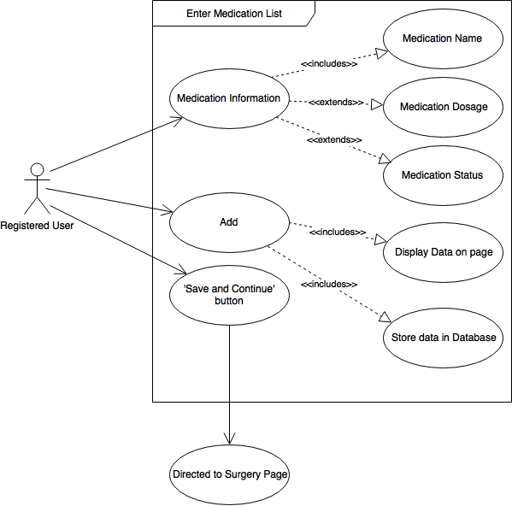

*Figure X: Enter List of Medications Use Case Diagram*

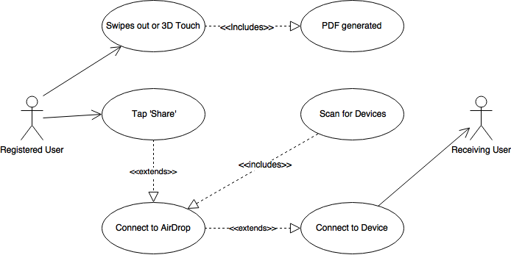

*Figure 9: Share Data to Another Device*

## 4.2 SEQUENCE DIAGRAMS

Login Sequence Diagram

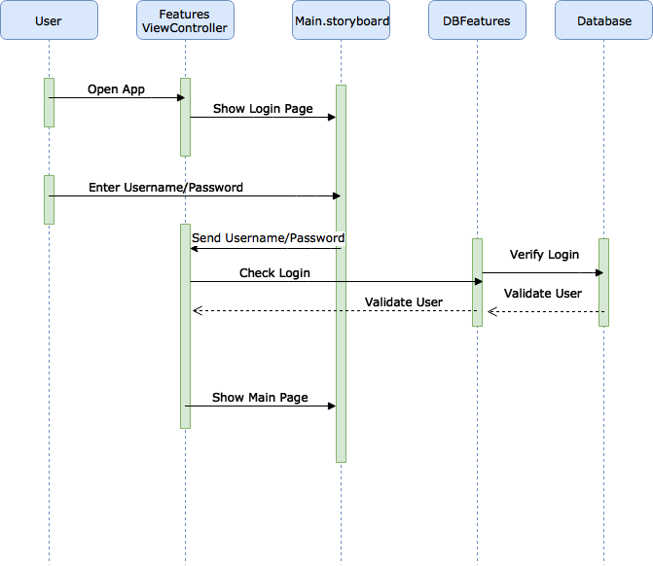

*Figure 10: Login Sequence Diagram*

Add Doctor(s) Name(s) Sequence Diagram

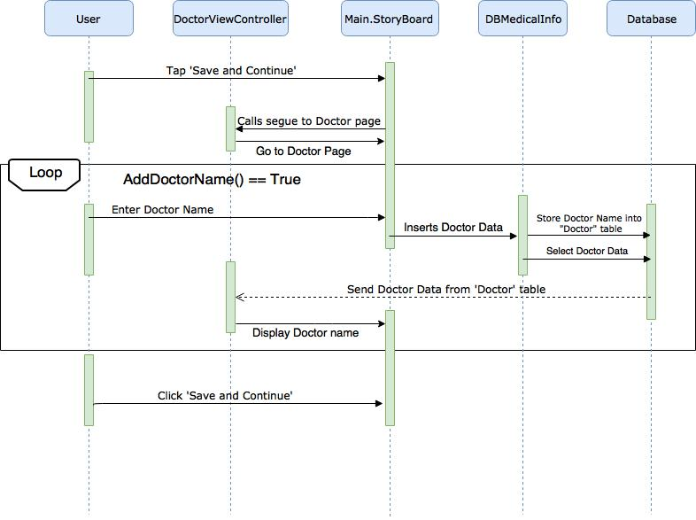

*Figure 11: Enter Doctor - Sequence Diagram*

Upload Document through Camera

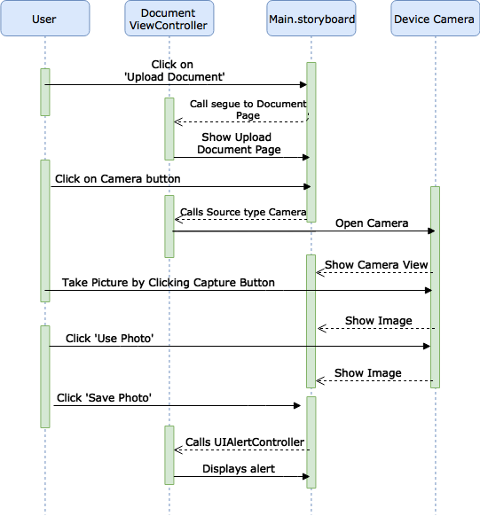

*Figure 12: Upload through Camera - Sequence Diagram*

Print Sequence Diagram

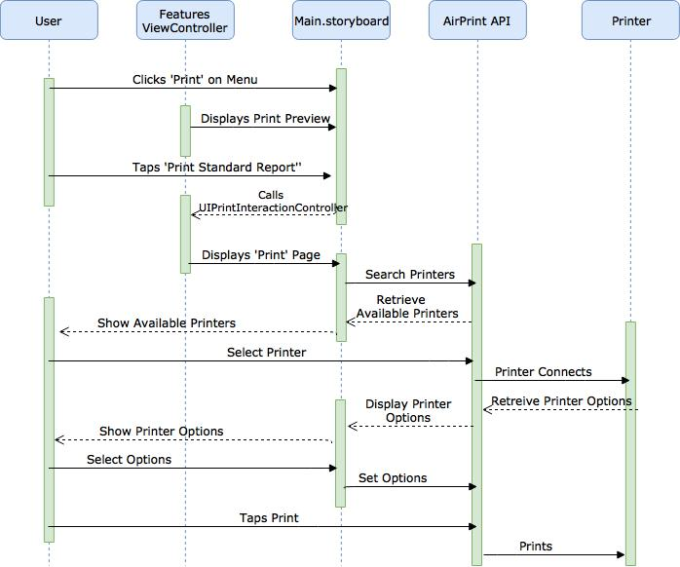

*Figure 13: Print - Sequence Diagram*

Sync Sequence Diagram

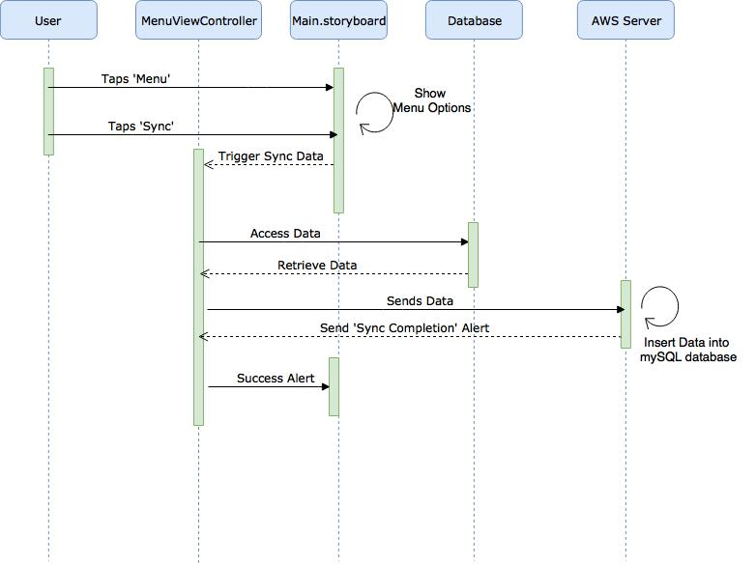

*Figure 14: Sync - Sequence Diagram*

Add Reminder Sequence Diagram

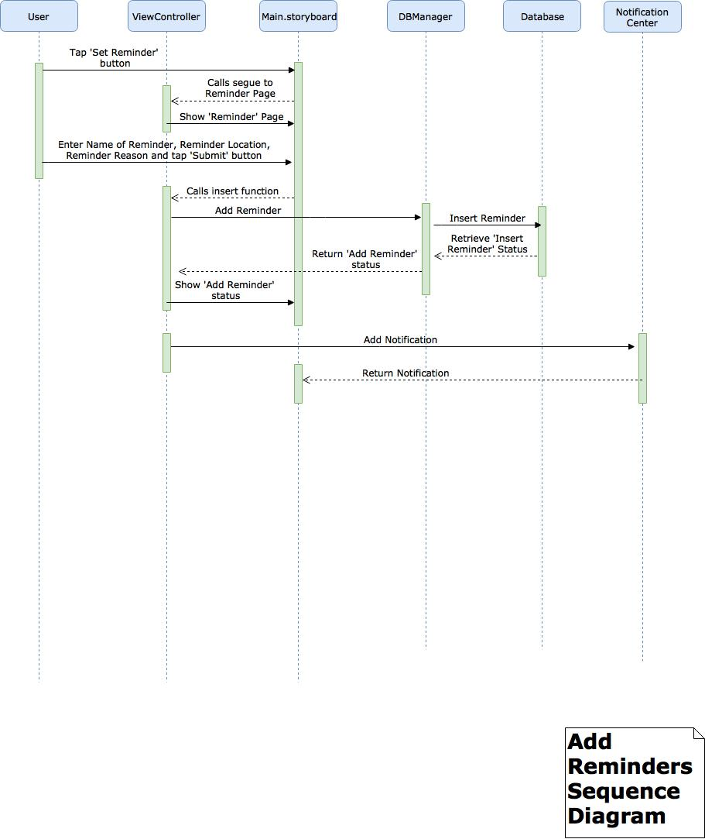

*Figure 15: Add Reminder - Sequence Diagram*

## 4.3 DATA FLOW DIAGRAM

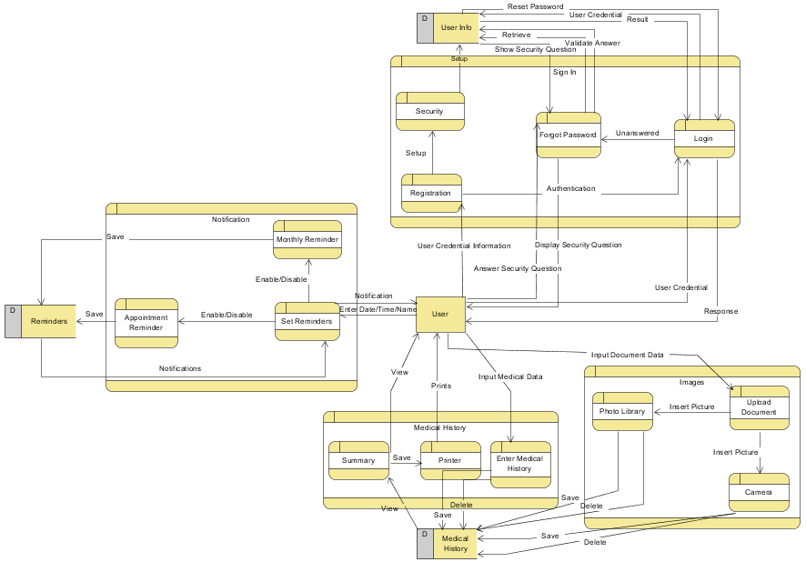

*Figure 16: Data Flow Diagram - Offline Version*

## onlinedataflow.PNG

*Figure 17: Data Flow Diagram Level Two - Online Version*

## 4.4 DATABASE DESIGN

## 

*Figure 18: Database Design – Offline Version*

## 

*Figure 19: Database Design – Online Version*

## 

## 

## 

## 

## 

## 

## 

## 4.5 CLASS DIAGRAM

The following class diagrams are for the viewcontrollers, database, and appdelegate.

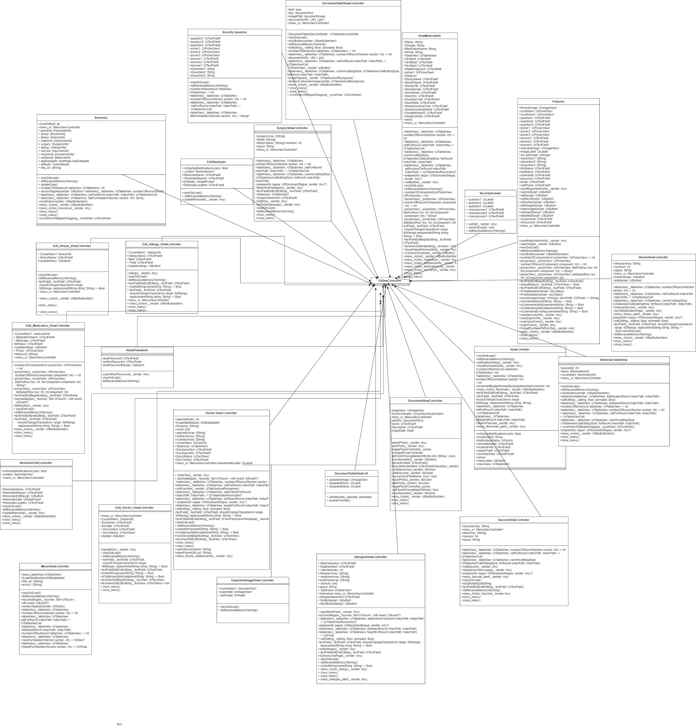

*Figure 20: View Controller Class Diagram - Offline*

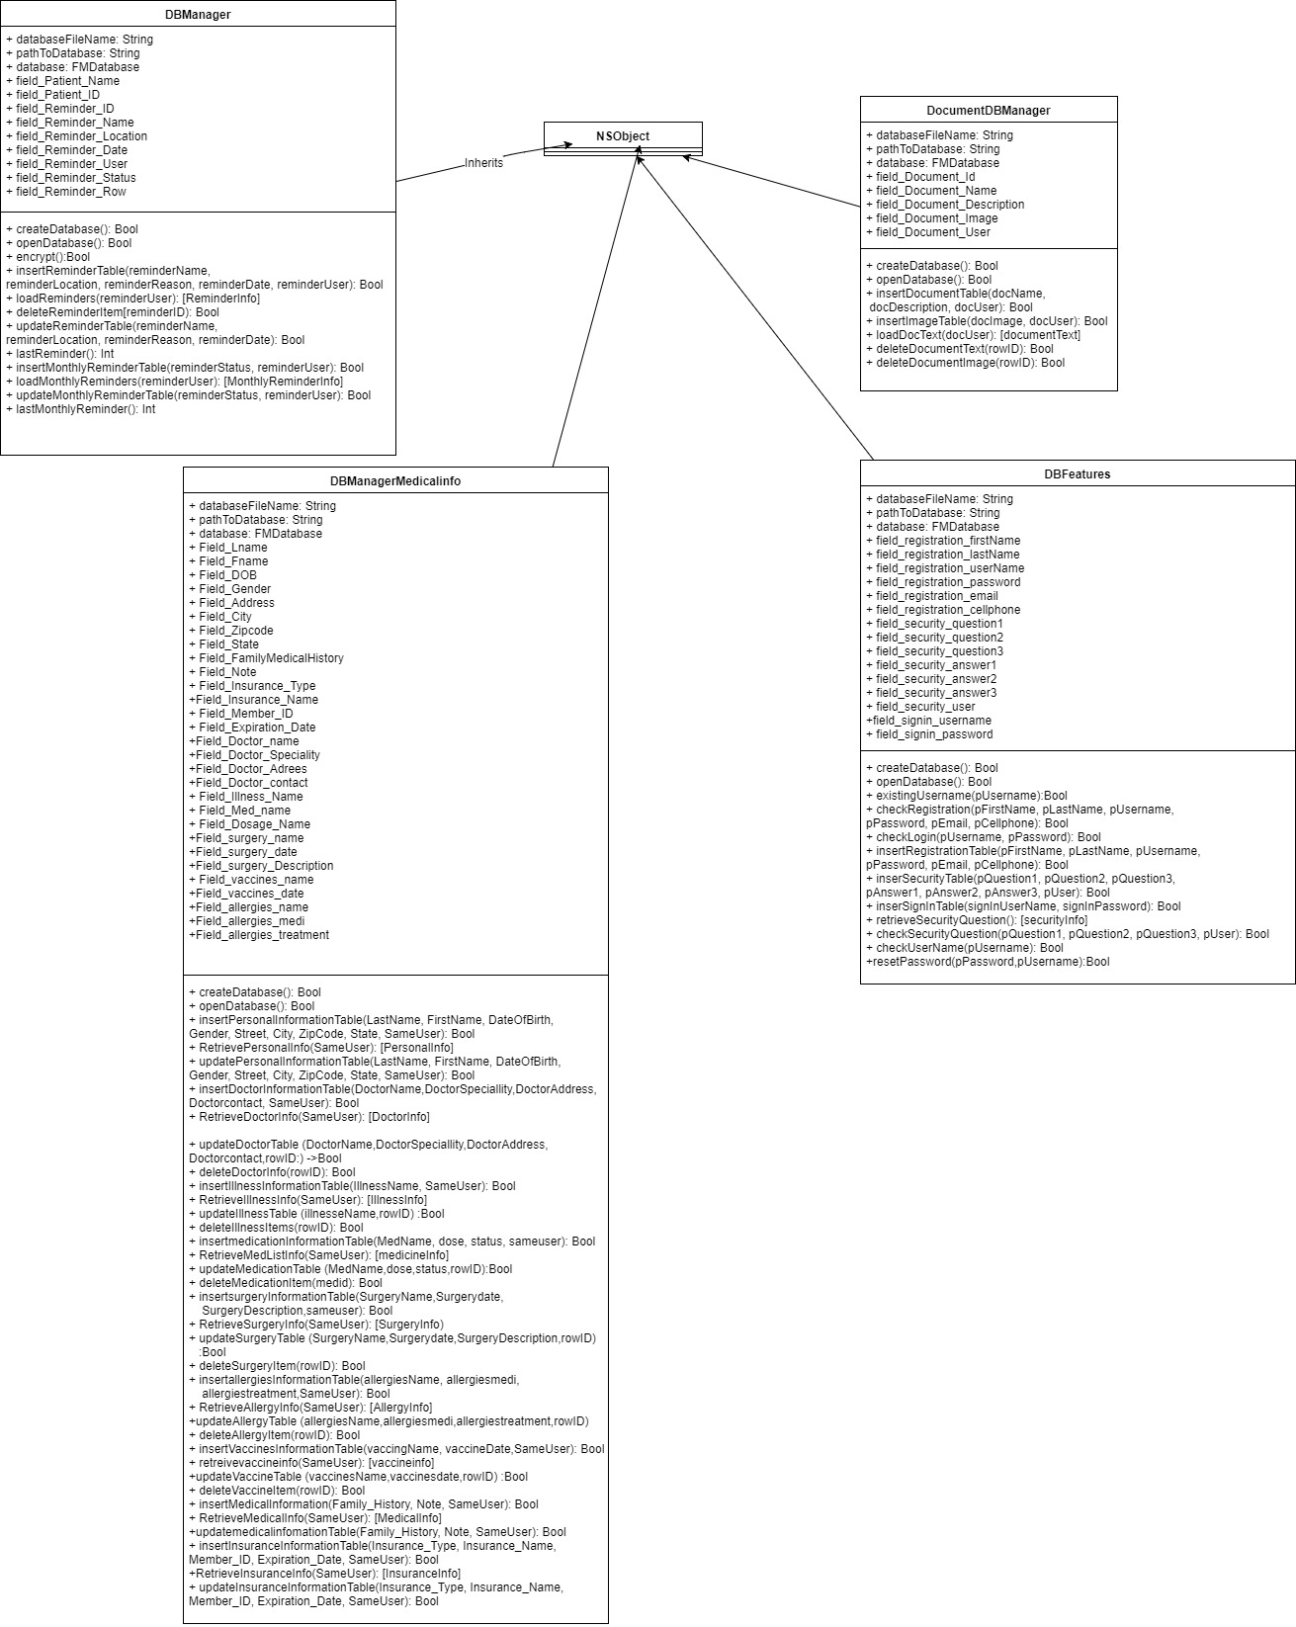

*Figure 21: Database Class Diagram - Offline*

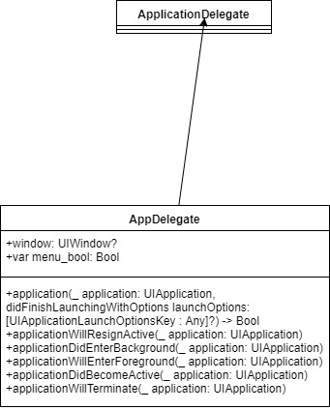

*Figure 22: AppDelegate Class Diagram - Offline and Online*

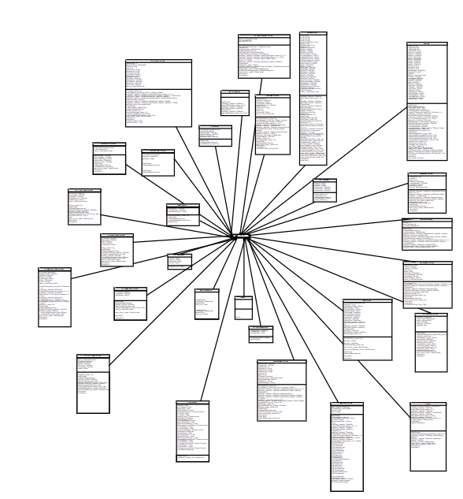

*Figure 23: View Controller Class Diagram - Online*

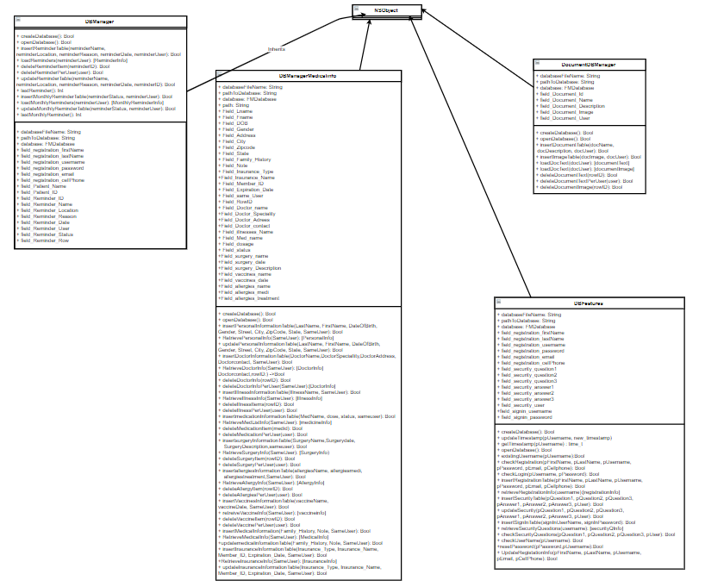

*Figure 24: Database Class Diagram - Online*

## 4.6 APPLICATION PROGRAM INTERFACES

### 4.6.1 SQLCipher:

This project will use the SQLCipher Community Edition for iOS and Mac OS X API in order to encrypt user’s personal information on the local SQLite database. This API uses a hashed and iterative function to create an encrypted key.

More information about the SQLCipher API can be found at <https://www.zetetic.net/sqlcipher/open-source/>

### 4.6.2 AirPrint:

This project will use the AirPrint API to print out a physical copy of the summary page and an image of an EKG onto an 8x11 paper for both the online and offline version. This API will also generate and save a PDF of the page.

The project will utilize the UIKit framework with the following functions to format the page and to print. This is subject to change as the project progresses.

* UIPrintInteractionController
* UIPrintInteractionControllerDelegate
* UIPrintPageRenderer
* UIPrintFormatter

More information can be found in <https://developer.apple.com/airprint/>.

### 4.6.3 AirDrop

This project will use the AirDrop API to give the user the ability to share a PDF of their medical summary with an uploaded image to nearby devices via Bluetooth.

More information can be found at <https://developer.apple.com/library/content/documentation/iPhone/Conceptual/iPhoneOSProgrammingGuide/Inter-AppCommunication/Inter-AppCommunication.html>

## 4.7 USER INTERFACE DESIGN

This Health App project consists of two main interfaces that patients will use: two iOS applications that will be in the form of an online application and an offline application.

When opening up the application, the user will first see the launch screen as shown in *Figure 25.* The login page appears next with an option to register, see *Figure 26*. To navigate to the registration page, the user will click on the ‘Click to Register’ button. The registration page consists of text fields for the user to input with an option to set an Email Address or Cellphone number, see *Figure 27*.

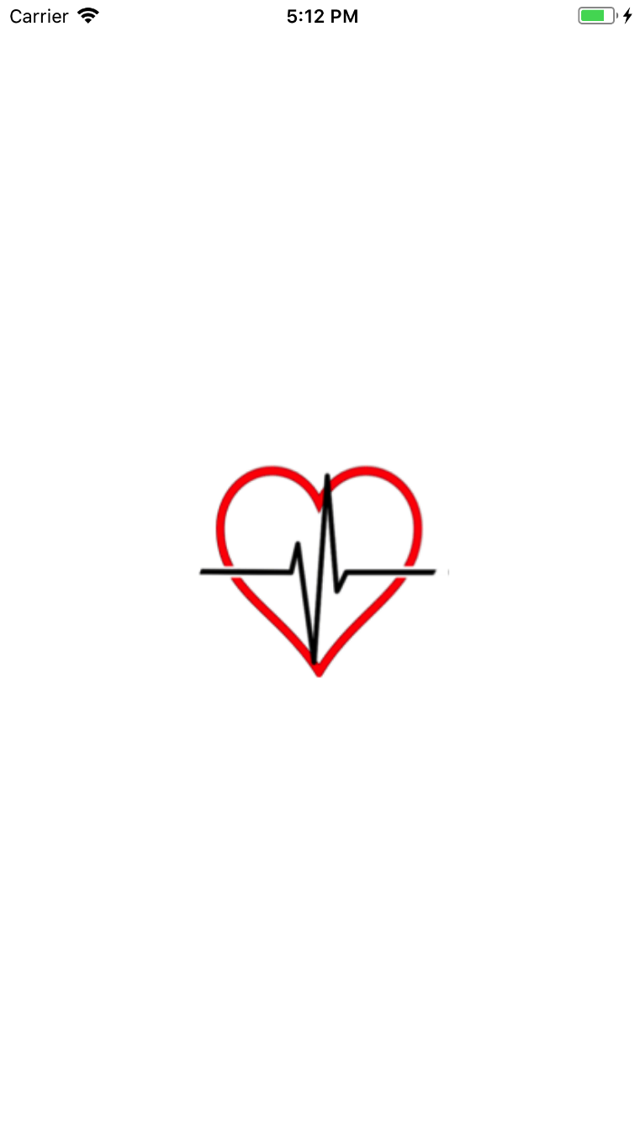

*Figure 25: launch screen*

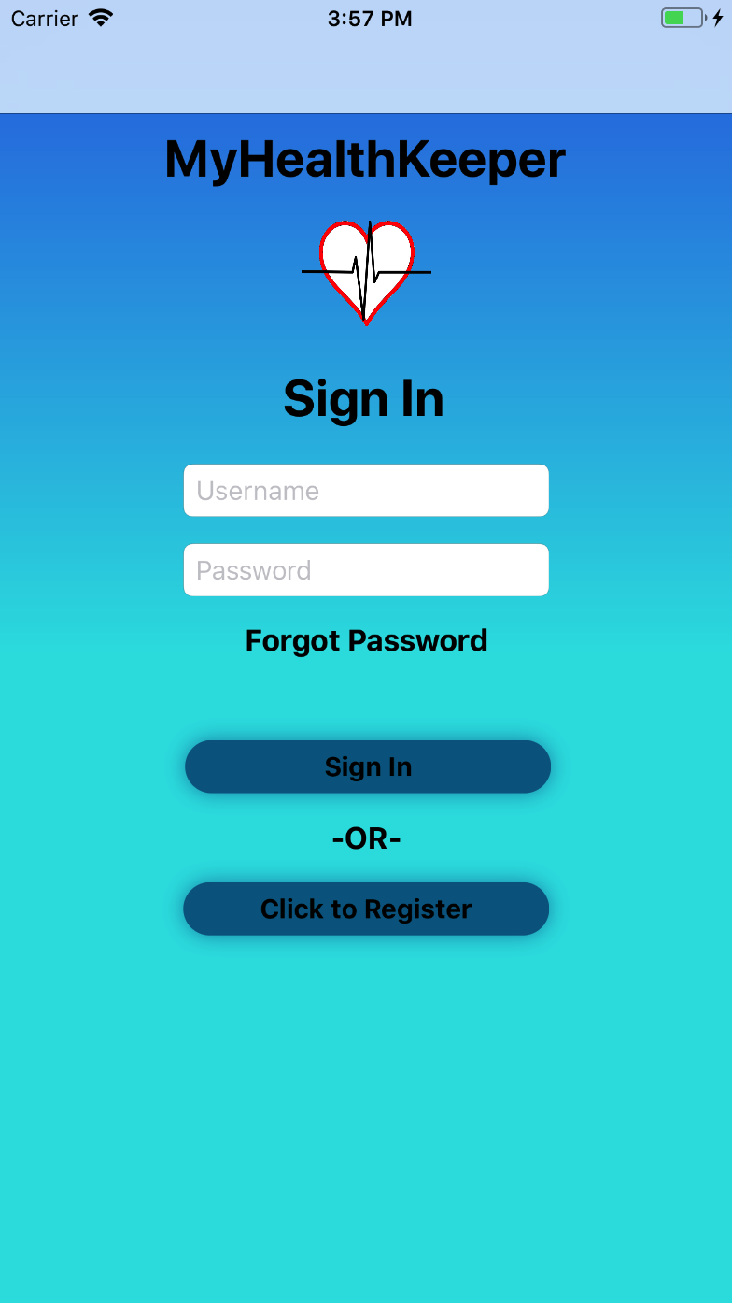 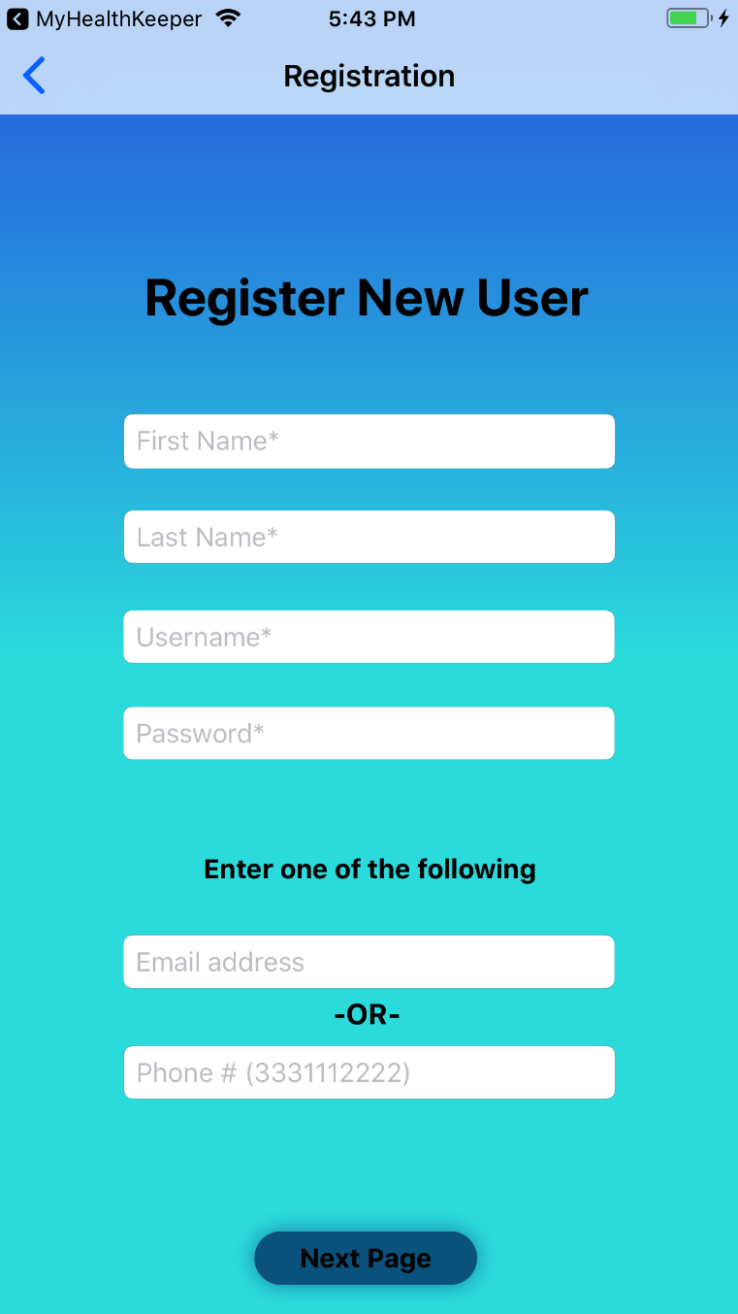

*Figure 26: Sign In* *Figure 27: Registration*

The user will be required to set answers to security questions as shown in *Figure 28*. If the user forgets their password when signing into the account, he or she will enter their username on the ‘Sign In’ page and click ‘Forgot Password’. They must be able to answer the security questions, shown in *Figure 29*, to log into their myHealthKeeper account. They will be directed to the ‘Reset Password’ page, as shown in *Figure 30,* to reset their password and directed back to the login page to login with their username and new password. This ensures access to the account is only given to the authorized person.

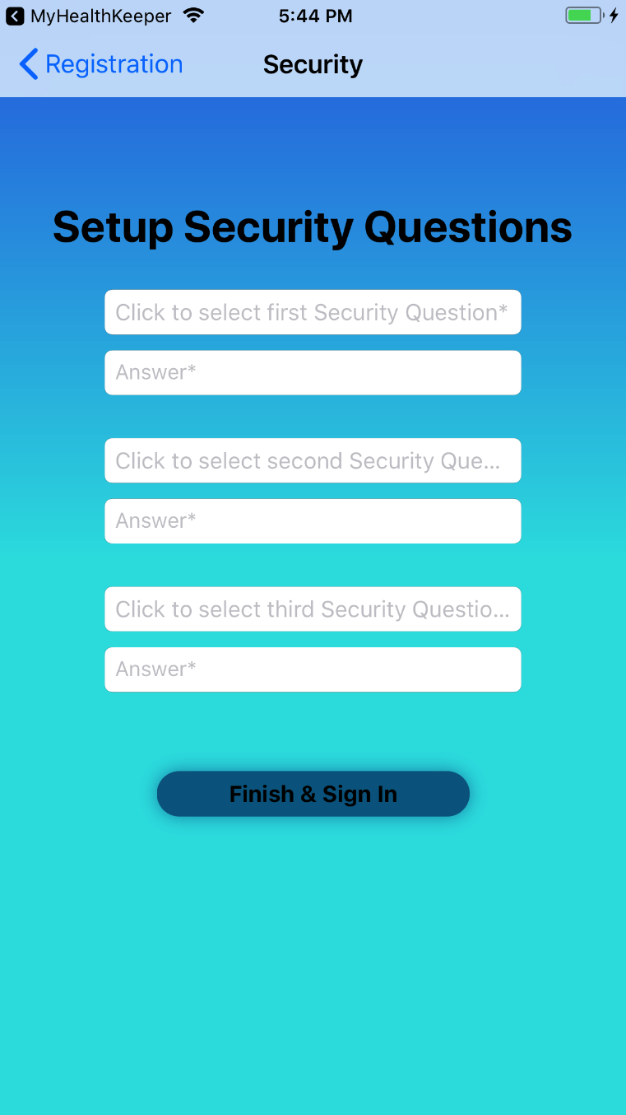 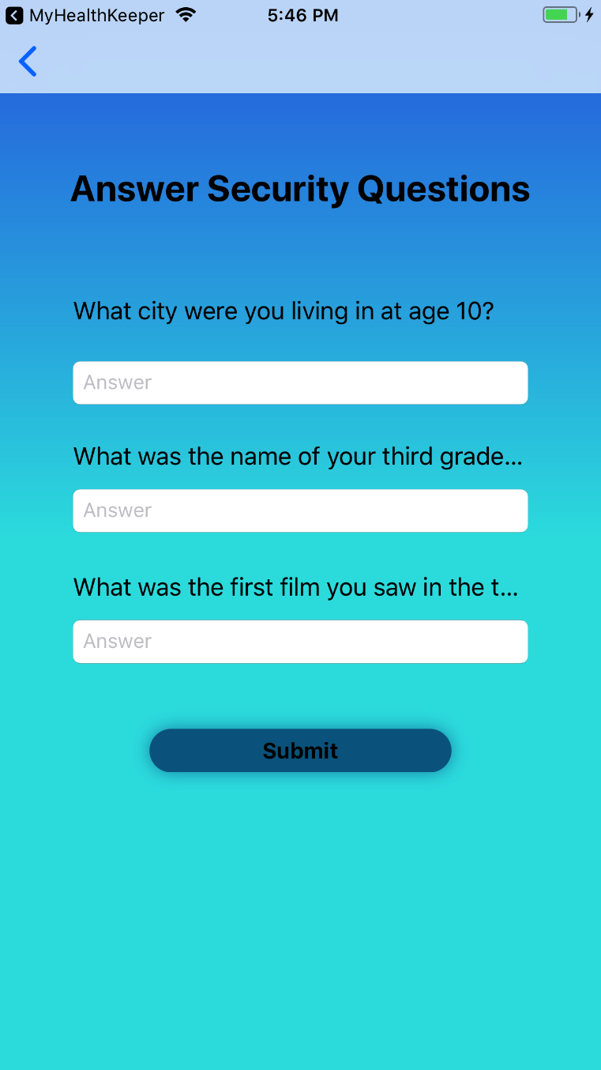

*Figure 28: Set Security Question* *Figure 29: Answer Security Question*

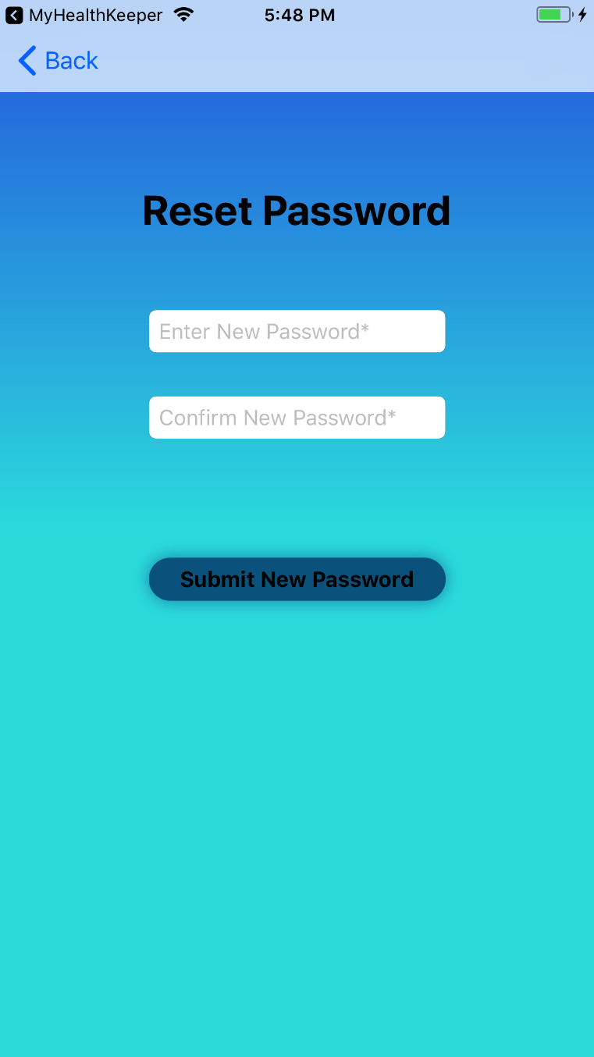 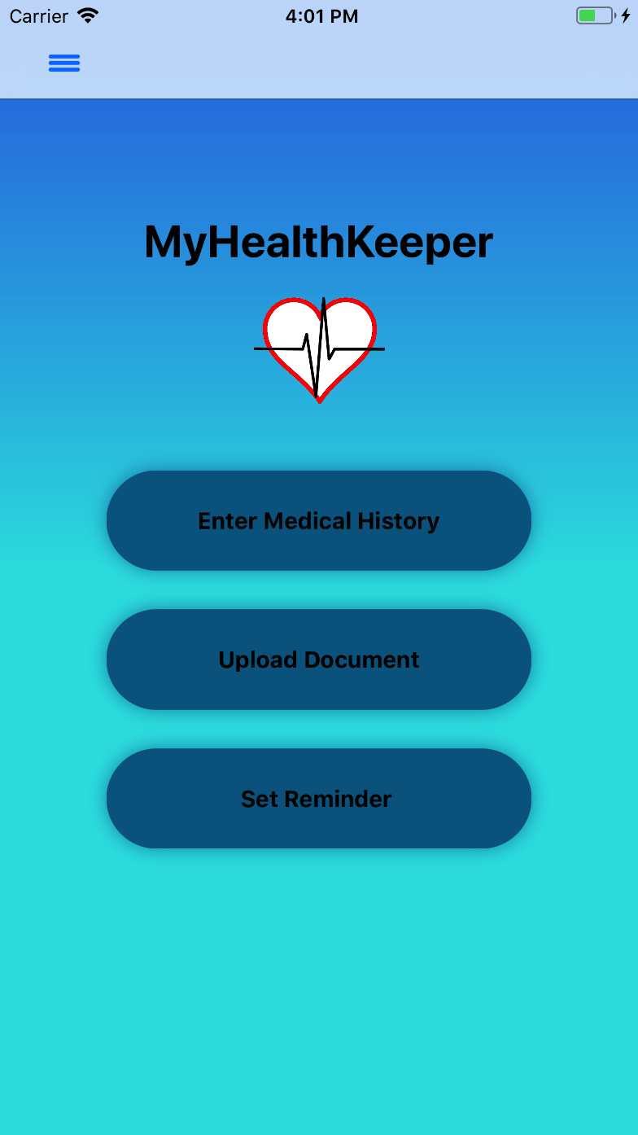

*Figure 30: Reset Password Figure 31: Main (Home)page*

Once login is successful, the main page of the application will be displayed. The user will be provided with three main options: Enter Medical Information, Upload Documents, and Set Appointment Reminders, *Figure 31*.

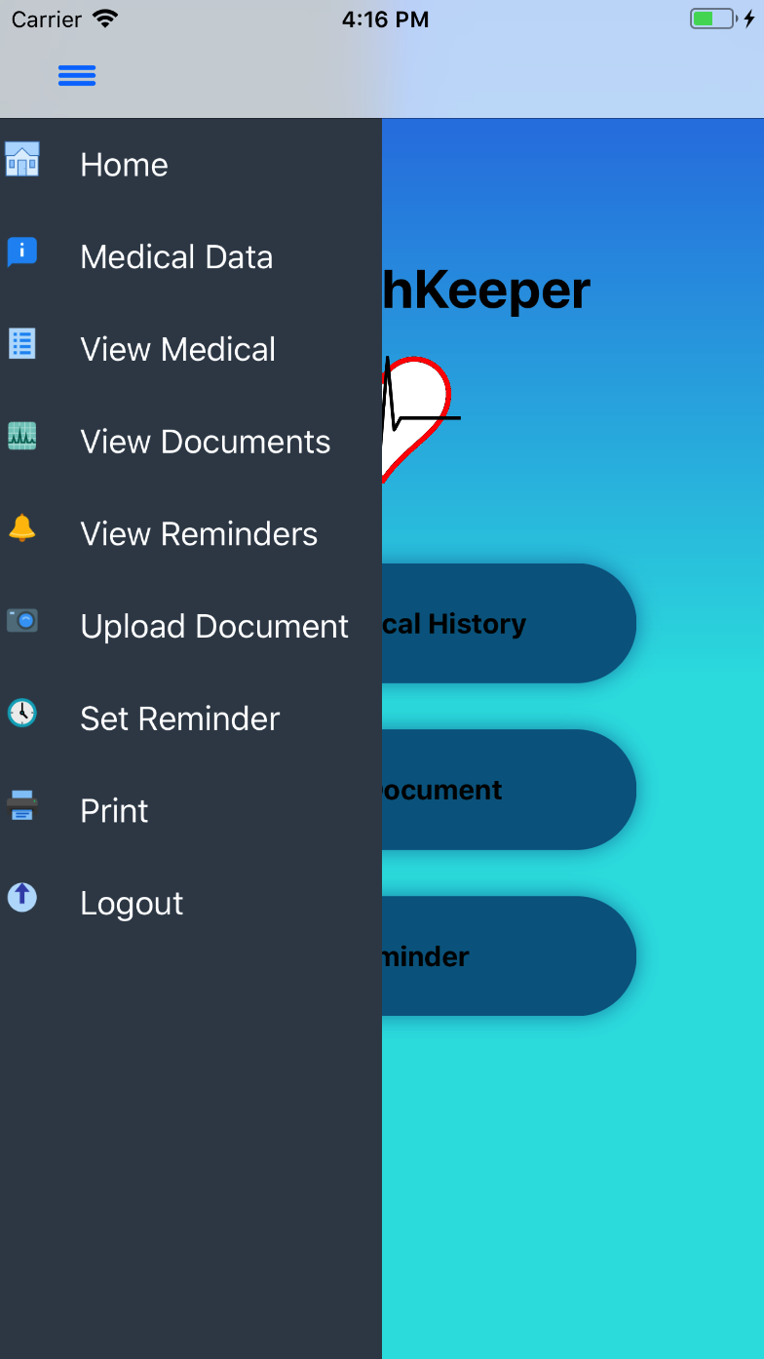 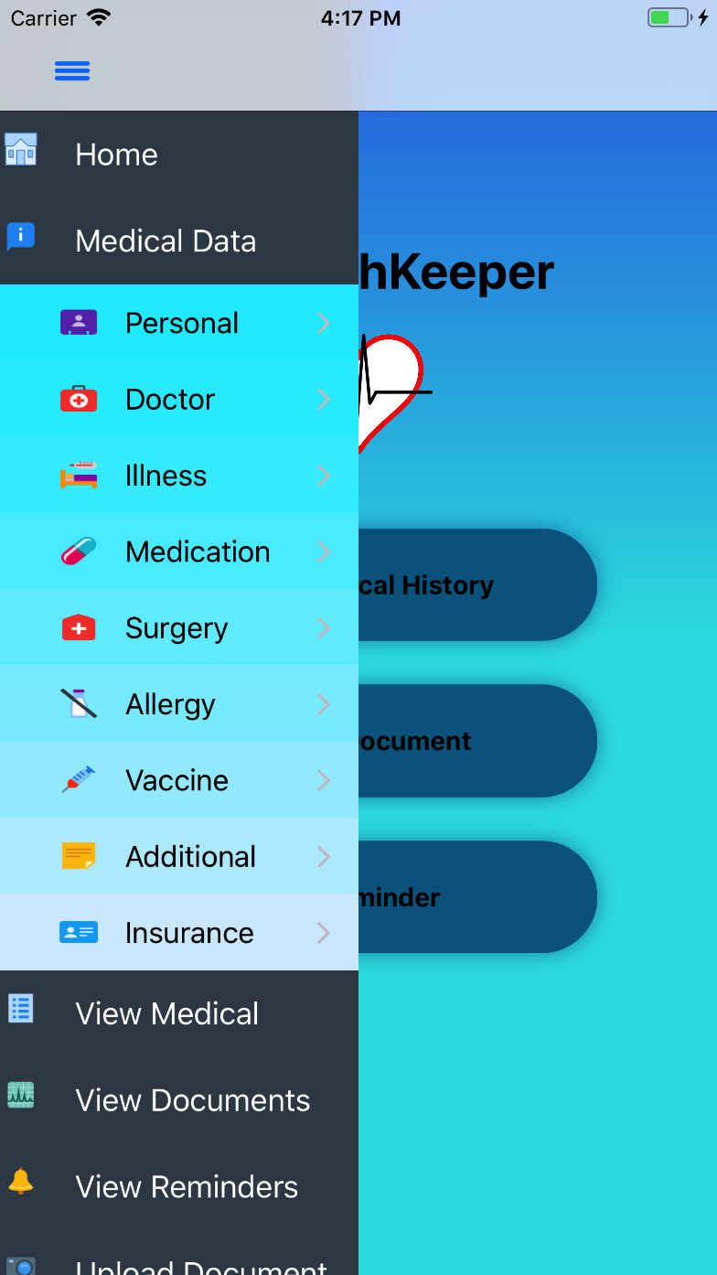

*Figure 32: Menu Figure 33: Expanded Menu*

Clicking on the arrow on the top of the page, see *Figure 32*, will display a slide-in menu where the user has several options to view summary pages. The user is also presented with an option to sign out of the app. This menu will be available in all pages after the user logs in. The options ‘Share’ and ‘Sync’ are only available in the online version. Clicking on ‘Medical Data’ will expand another Menu containing the Medical pages the user can navigate to, see *Figure 33.*

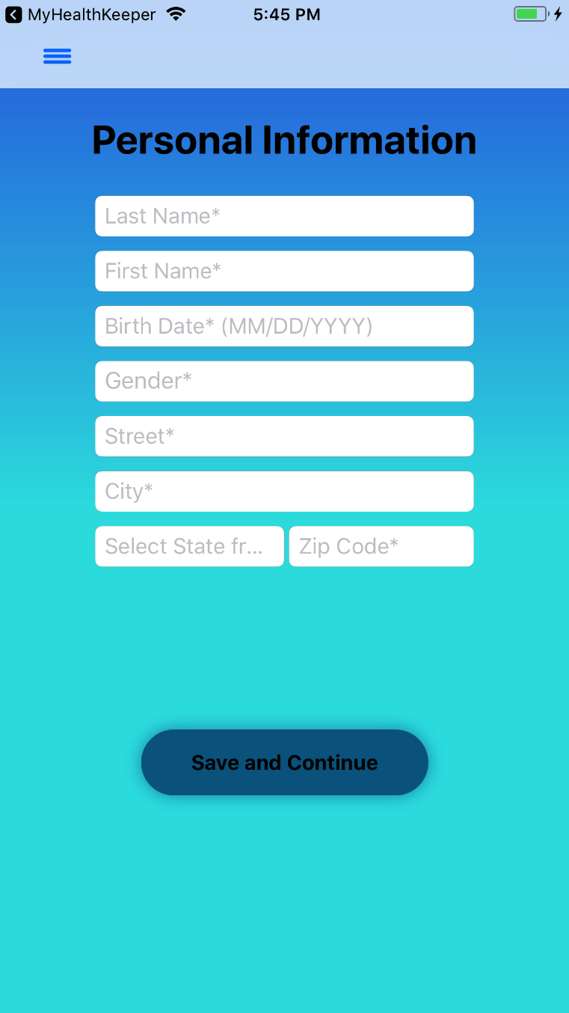 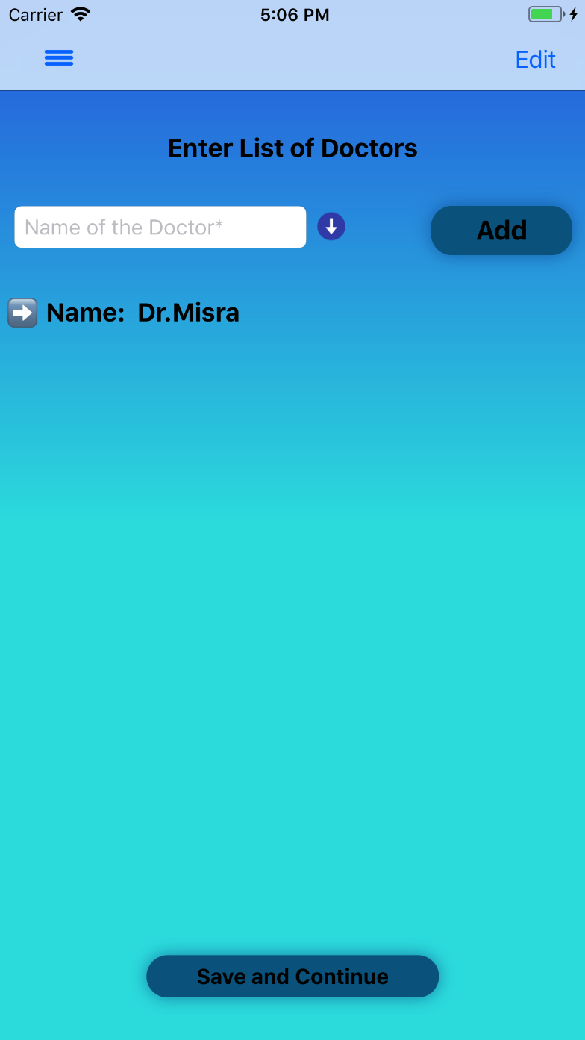

*Figure 34: Personal information Figure 35: Doctor page*

The user can enter their Personal Information as shown in *Figure 34.* Once the Personal Information has been entered, the user will tap ‘Save and Continue’. The user is then directed to the Enter List of Doctors page to enter their Doctor Information, see *Figure 35.*

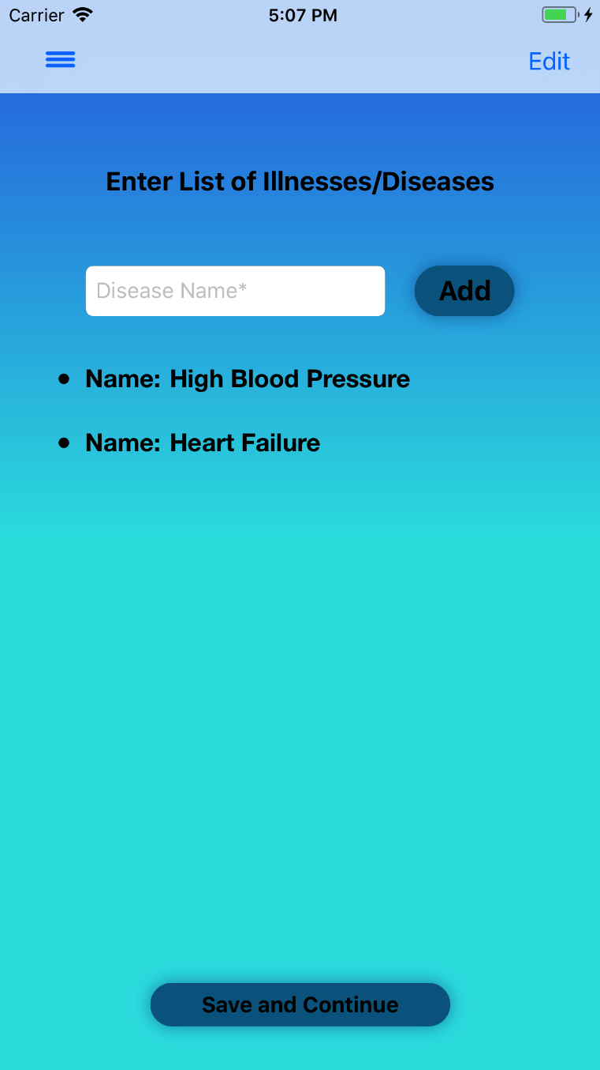 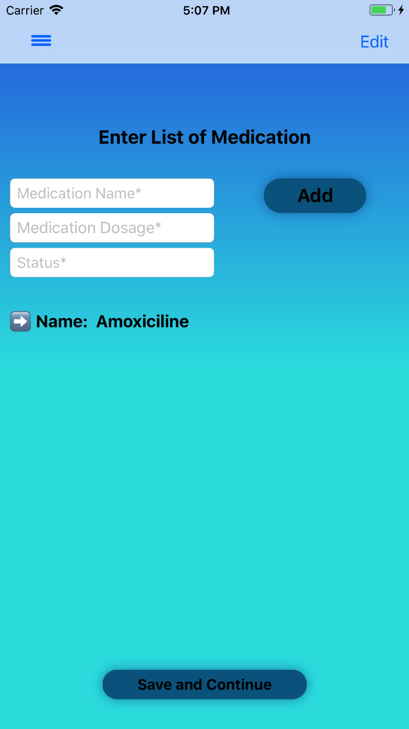

*Figure 36: Illness page Figure 37: Medication page*

Once the Doctor Information has been entered, the user will tap ‘Save and Continue’. The user is then directed to the Enter List of Illnesses/Disease page to enter their Illness Information, see *Figure 36.* Once the Illness/Disease Information has been entered, the user will tap ‘Save and Continue’. The user is then directed to the Enter List of Medication page to enter their Medication Information, see *Figure 37.*

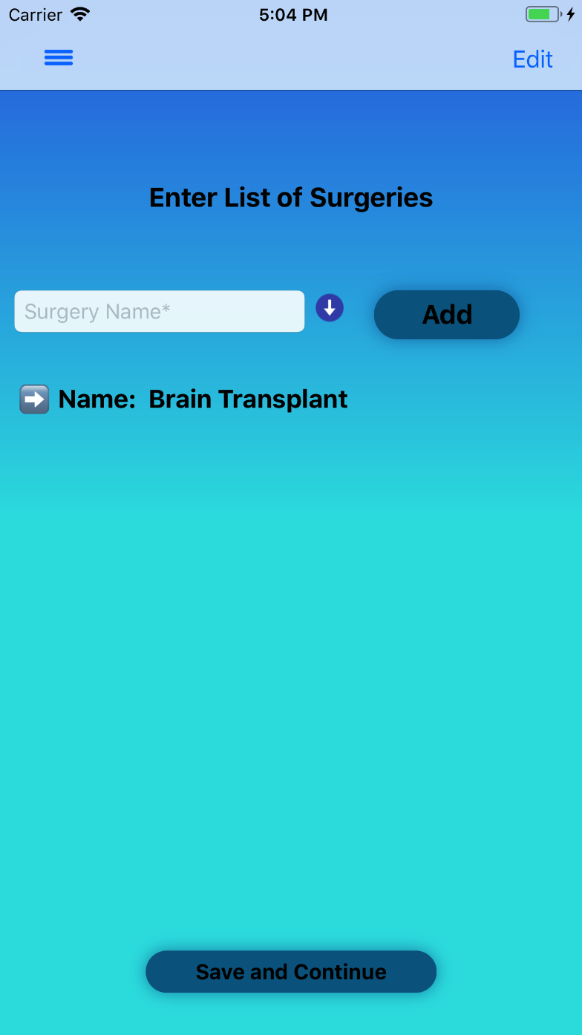 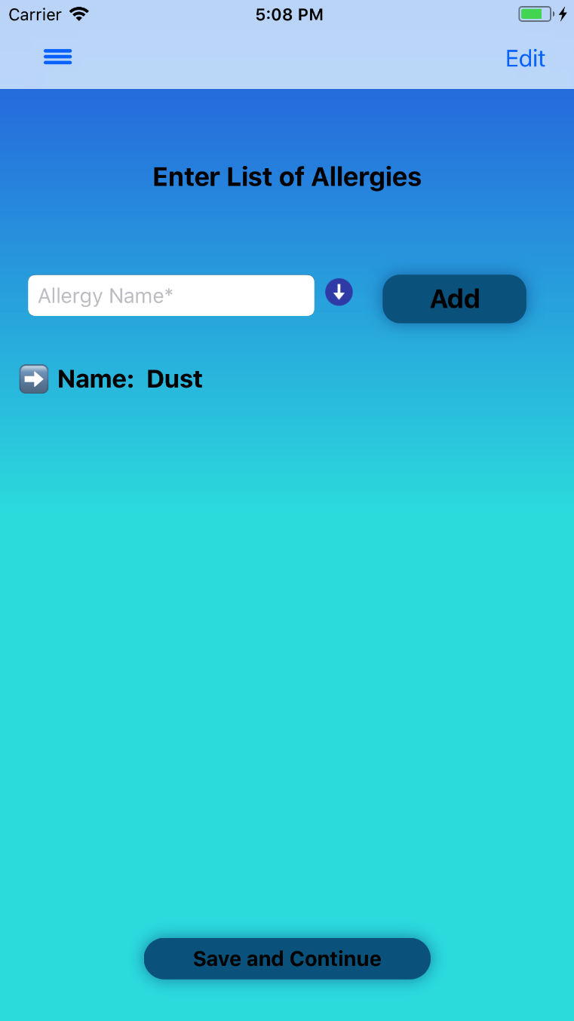

*Figure 38: Surgery Figure 39: Allergy*

Once the Medication Information has been entered, the user will tap ‘Save and Continue’. The user is then directed to the Enter List of Surgeries page to enter their Surgery Information, see *Figure 38.* Once the Surgery Information has been entered, the user will tap ‘Save and Continue’. The user is then directed to the Enter List of Surgeries page to enter their Medication Information, see *Figure 39.*

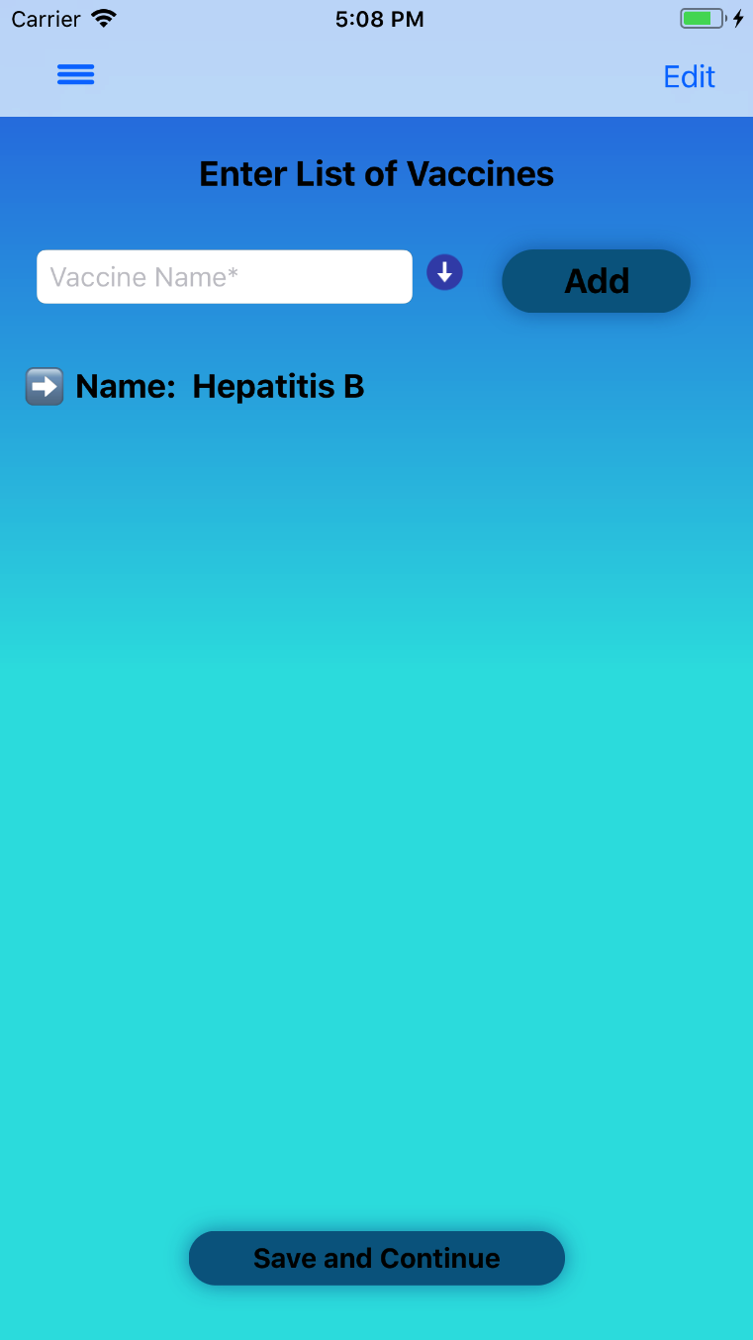 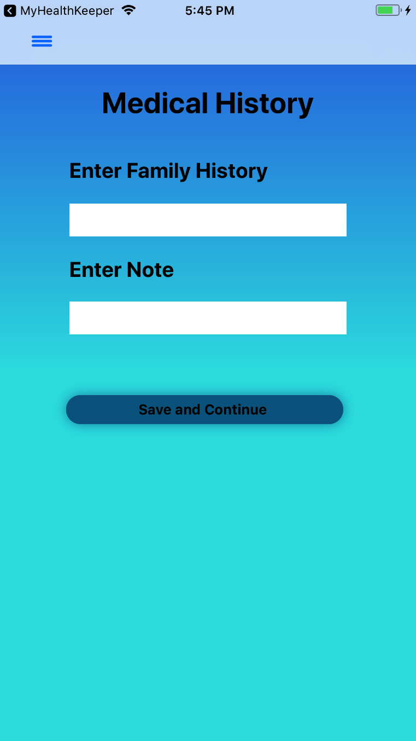

*Figure 40: Vaccine Figure 41: Family medical history*

Once the Allergy Information has been entered, the user will tap ‘Save and Continue’. The user is then directed to the Enter List of Vaccines page to enter their Vaccine Information, see *Figure 40.* Once the Surgery Information has been entered, the user will tap ‘Save and Continue’. The user is then directed to the Medical History page to enter their Family History and Notes, see *Figure 41.*

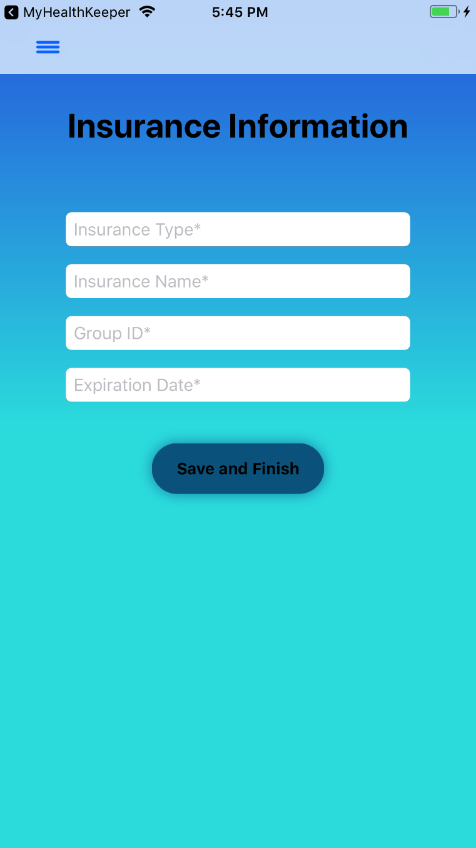 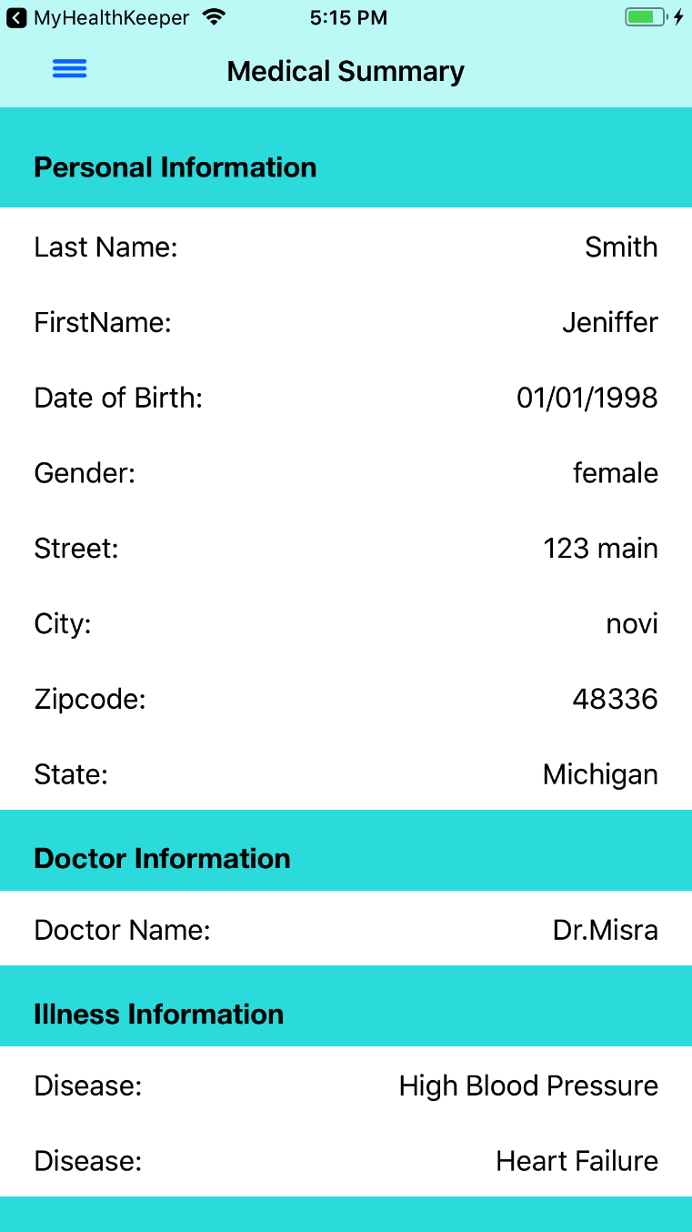

*Figure 42: Insurance Info Figure 43: Medical summary*

Once the Medical History has been entered, the user will tap ‘Save and Continue’. The user is then directed to the Enter Insurance Information page to enter their Insurance Information, see *Figure 42.* Once the Insurance Information has been entered, the user will tap ‘Save and Continue’. The user can be direct to the Medical Summary page to view their Medication Information, see *Figure 43.*

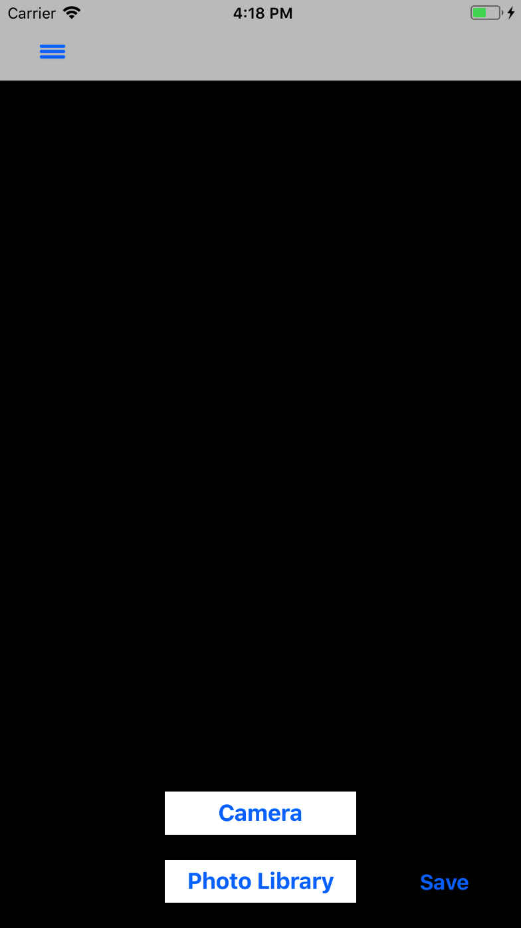 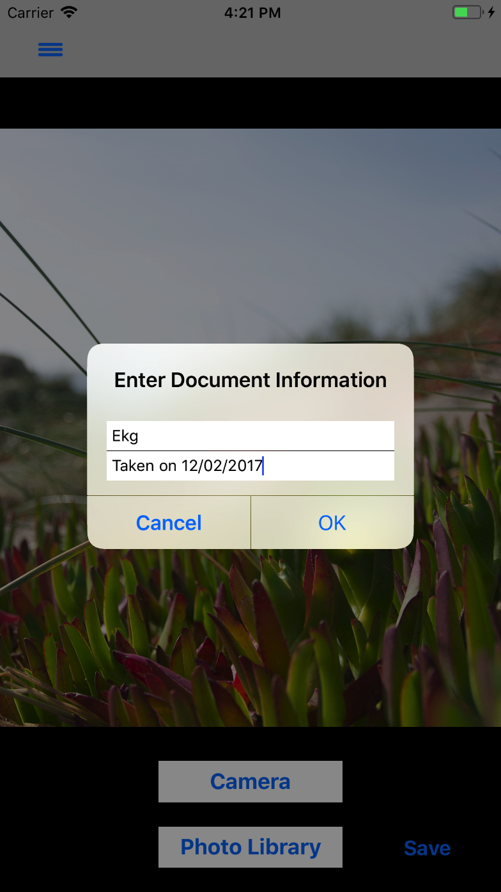

*Figure 44: Upload Document Figure 45: Enter Document Information*

The User can Upload a Document via their iOS device’s camera or their iOS device’s Photo Library as shown in *Figure 44.* When an image is selected to be uploaded, an alert with the Document Name and Document Description to be entered appears on the screen, see *Figure 45.*



*Figure 46: Uploaded Documents*

The user can then view their uploaded documents through a Document Summary page as seen in *Figure 46.*

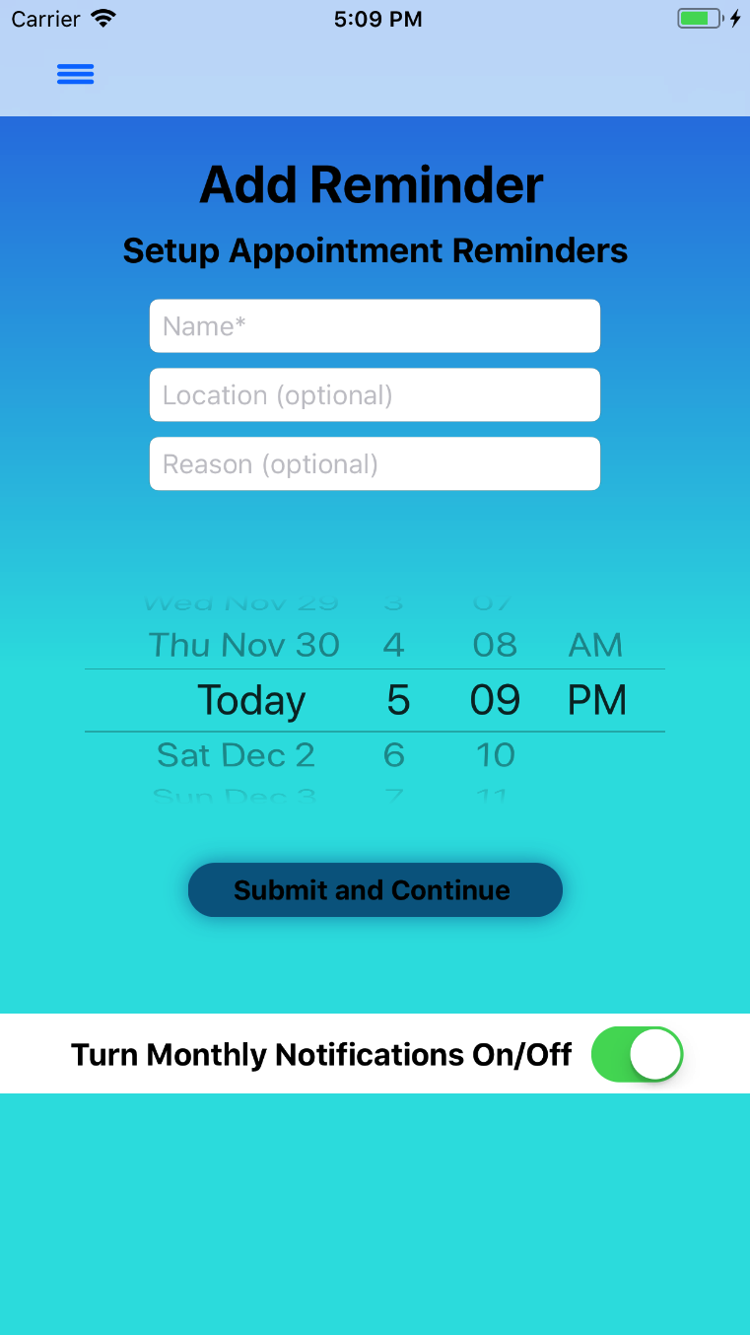 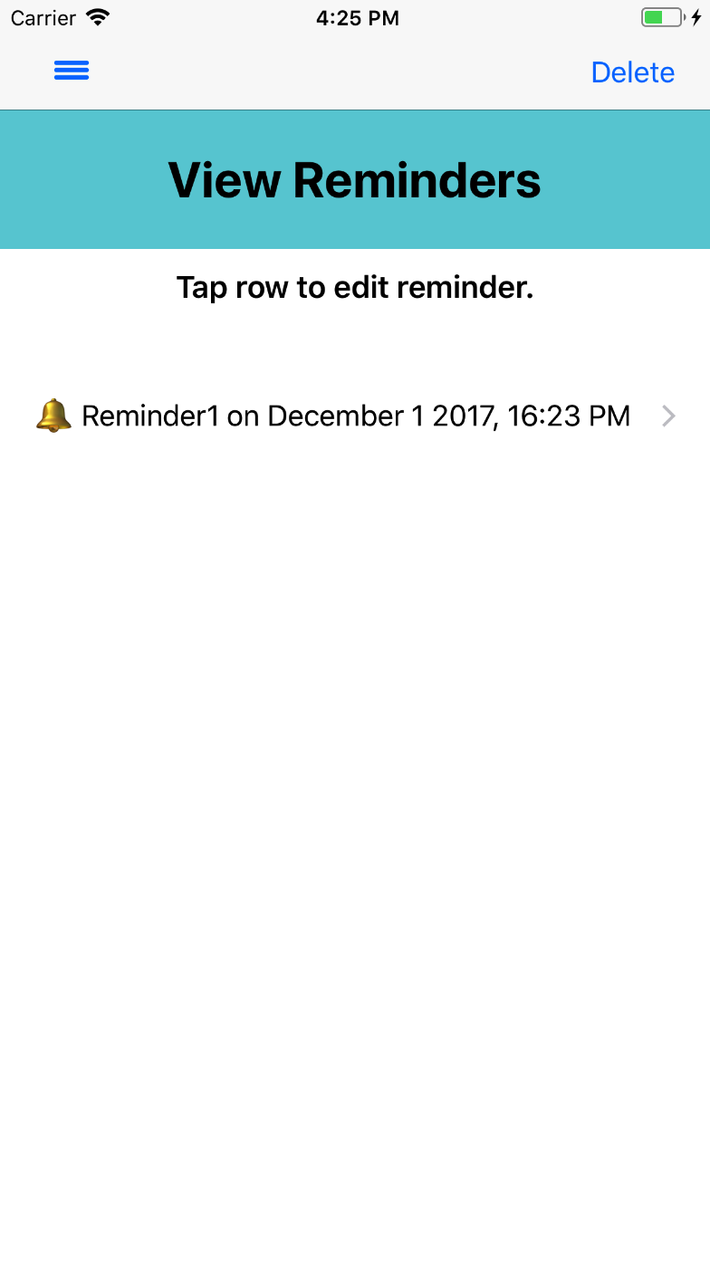

*Figure 47: Add Reminder Figure 48: View reminders*

The User can then be directed to Set a Reminder as seen in *Figure 47*. The User enters their Reminder information in the designated text fields and taps ‘Submit and Continue’. An alert appears with a message to View Reminders. The User is directed to the View Reminders page where they can view or edit their existing reminders, see *Figure 48.*

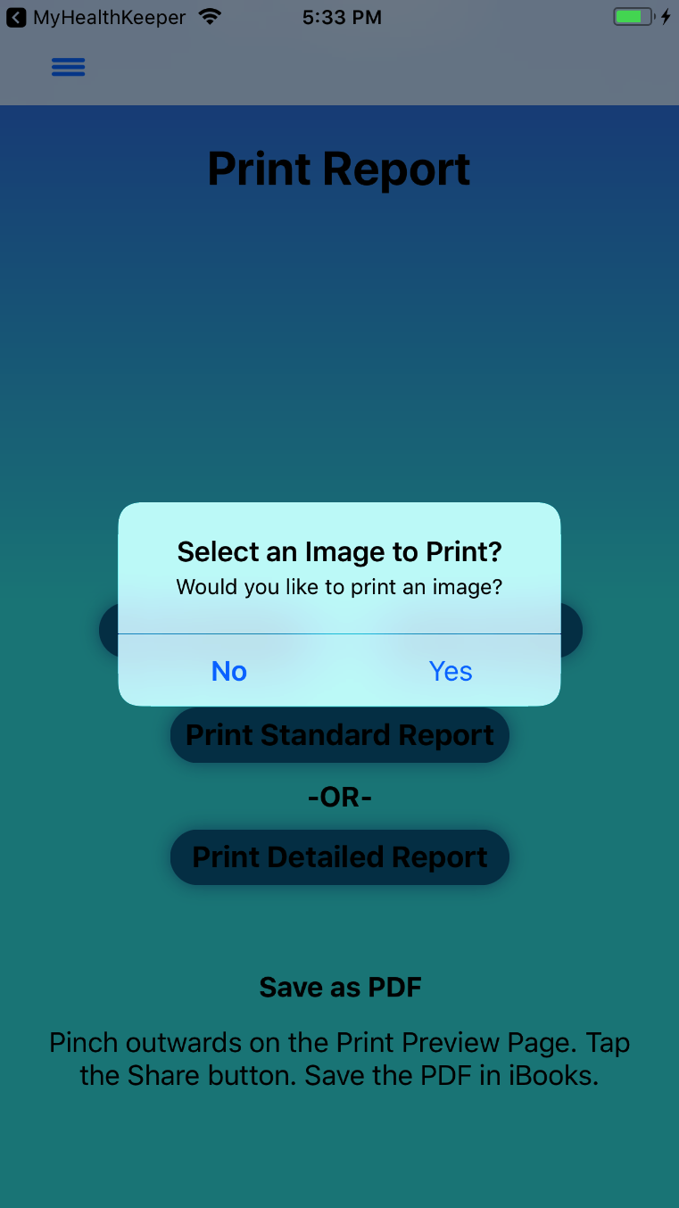 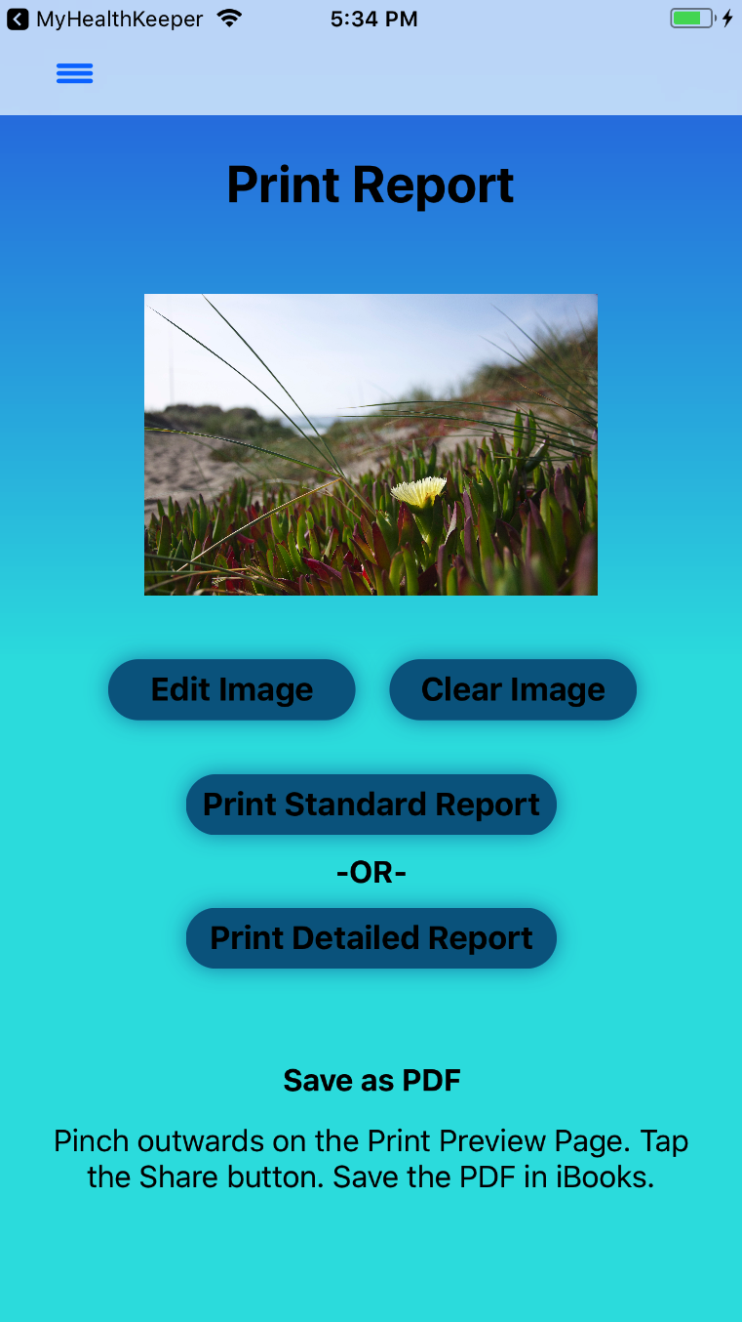 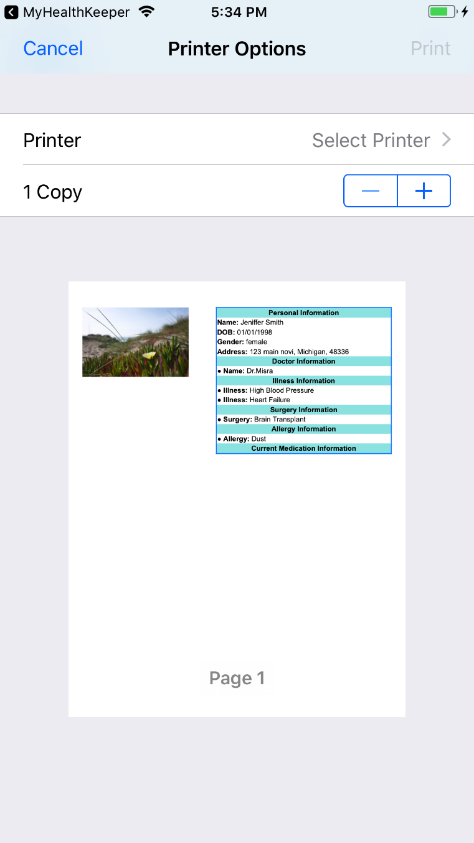*Figure 49: Image for Report Figure 50: Image for Report Figure 51: Report with Image*

If the user wants to Print their information, they can tap ‘Print’ from the Menu, and will be directed to the Print Report page where they will be presented with an alert, see *Figure 49*. If ‘Yes’ is selected, they are directed to the Uploaded Documents page to select an image to Print. They are redirected back to the Print Report page with their selected image, see *Figure 50.* The User can then select ‘Print Standard Report’ or ‘Print Detailed Report’, and will be directed to the Printer Options page, see *Figure 51 and Figure 52.*

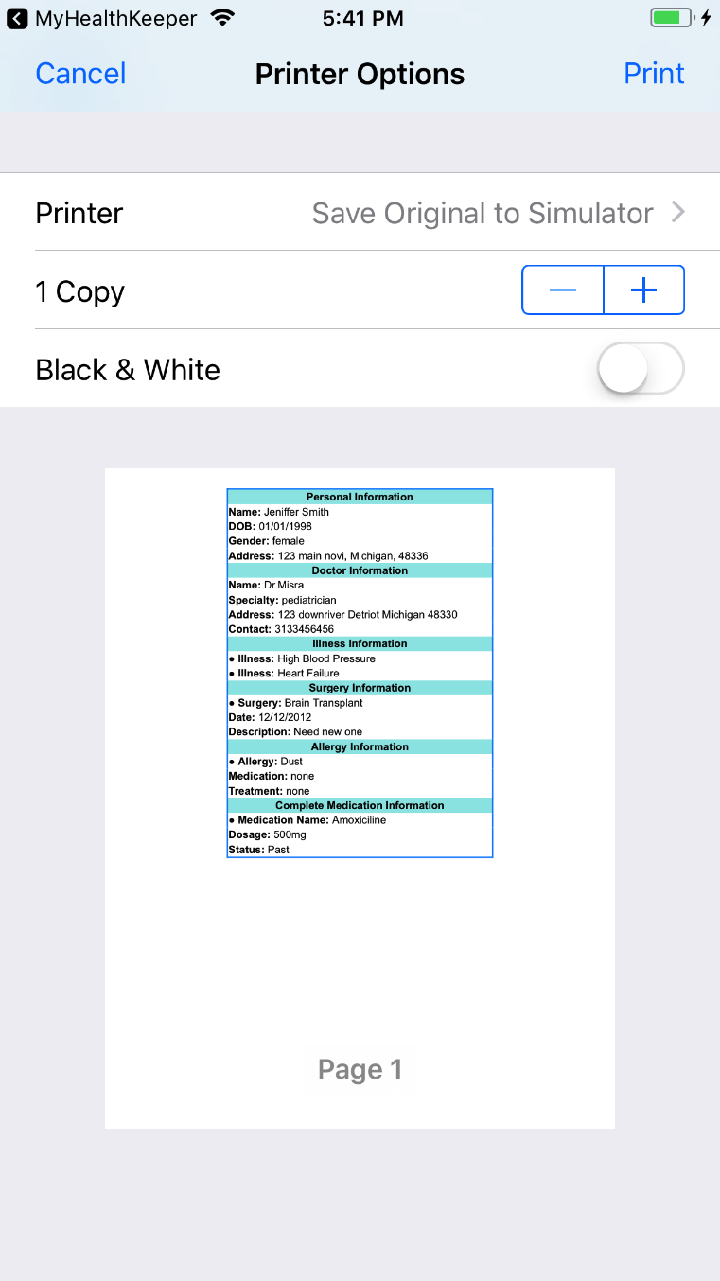 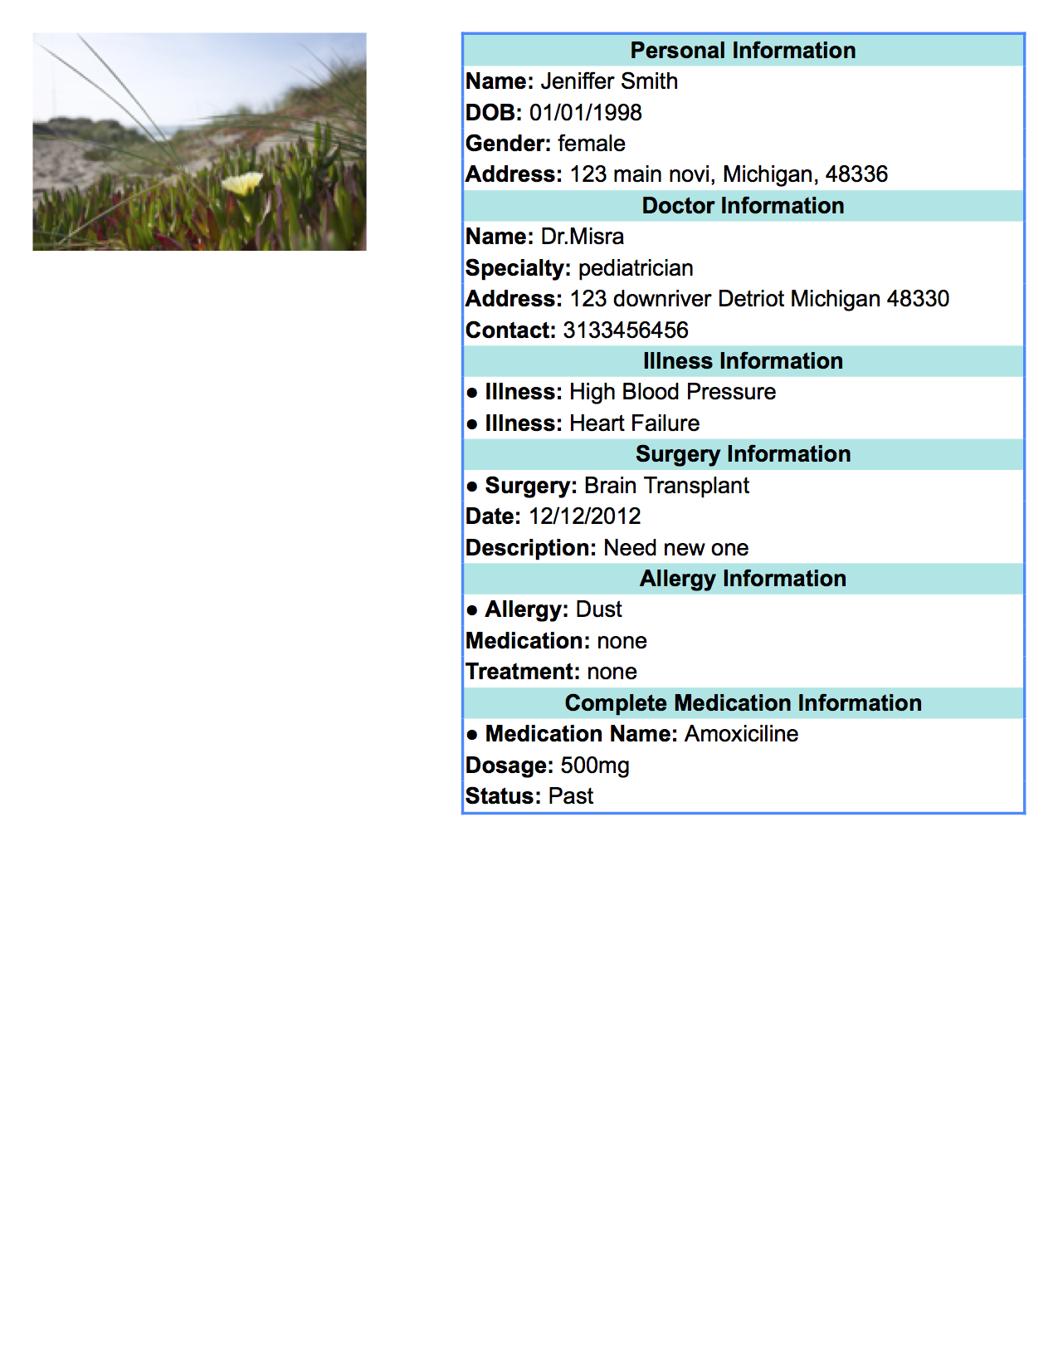

*Figure 52: Report without Image Figure 53: Printed Report*

Once printed from an AirPrint enabled printer, the report will look as shown in *Figure 53.* To save the report as a PDF, the user can swipe out or use 3D touch to expand the report image. The user can tap on the Share icon, and select ‘Import with iBook’ as shown in *Figure 54.*

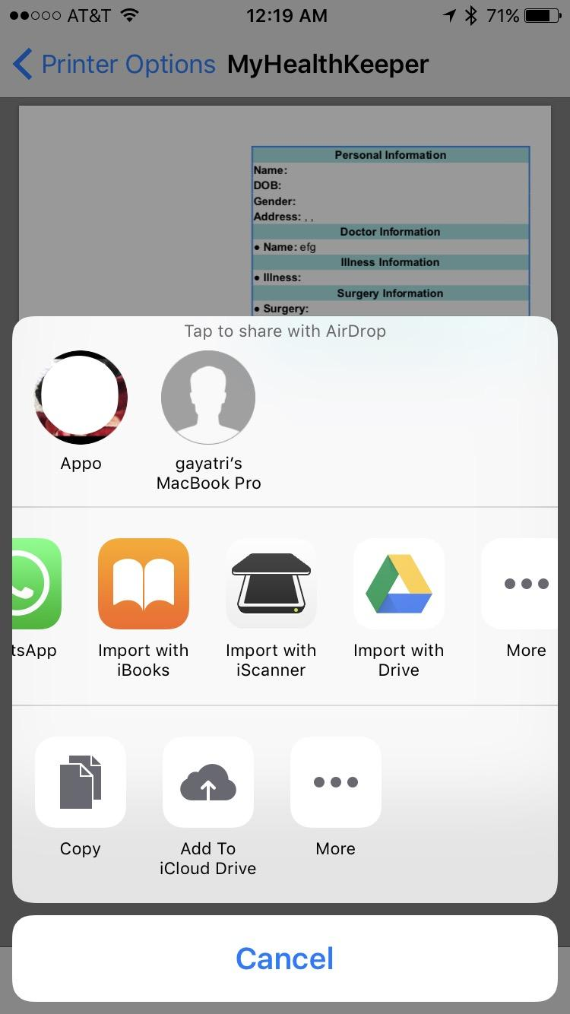

*Figure 54: Export as PDF*

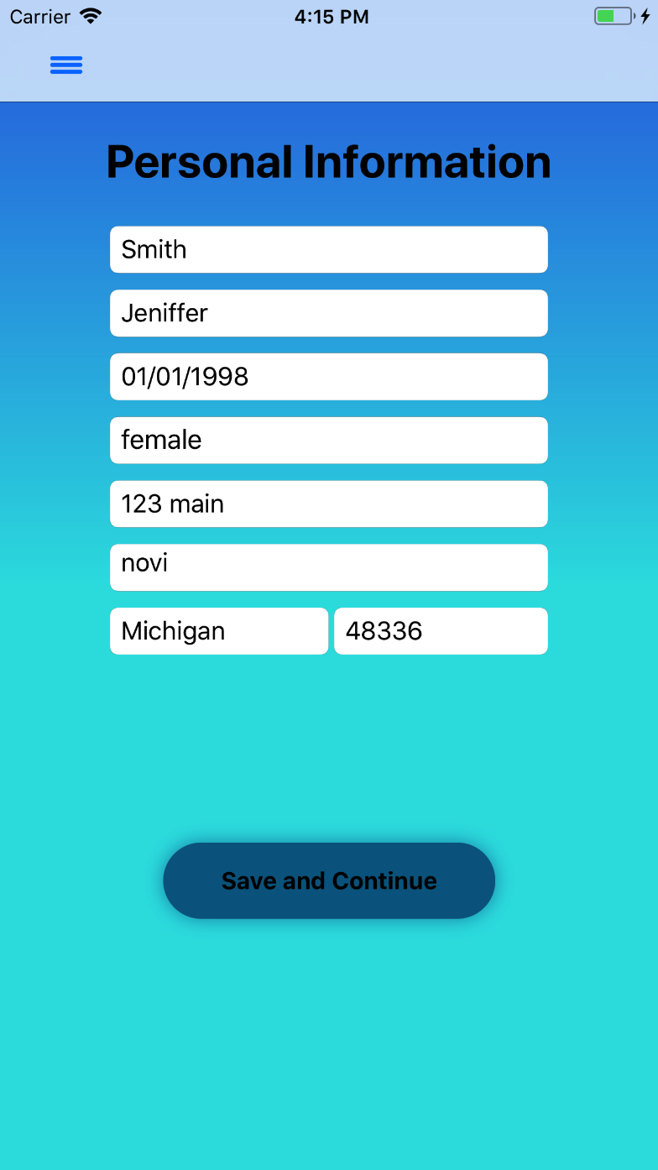 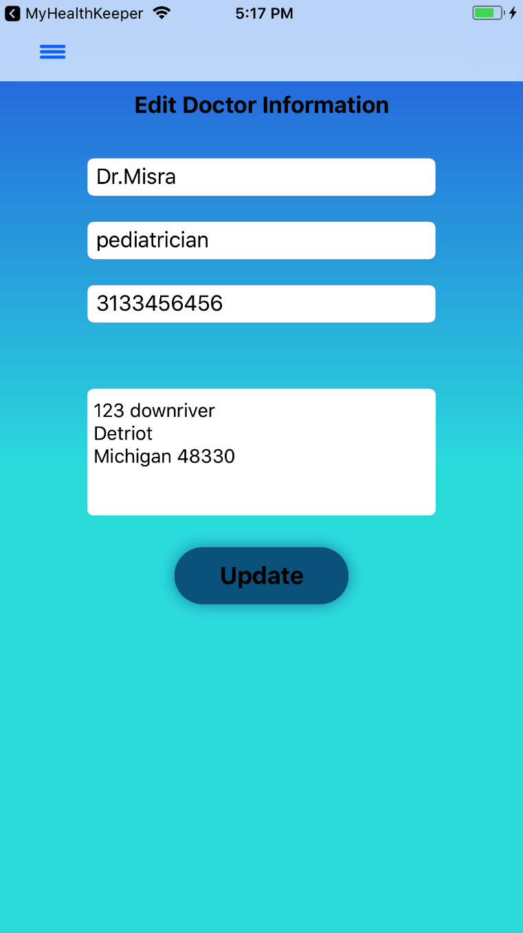

*Figure 55: Edit Personal Information Figure 56: Edit Doctor Information*

If the user wants to edit their Personal Information, they can navigate to that page (where their current data will populate the text fields), make any necessary changes, and tap on ‘Save and Continue’ as shown in *Figure 55.* To edit Doctor Information, the user can tap ‘Edit’ in the top- right corner, select the information they want to edit, and their data will populate the text fields as shown in *Figure 56.* The user then taps ‘Update’ and will be redirected back to the Enter List of Doctors page with their updated information.

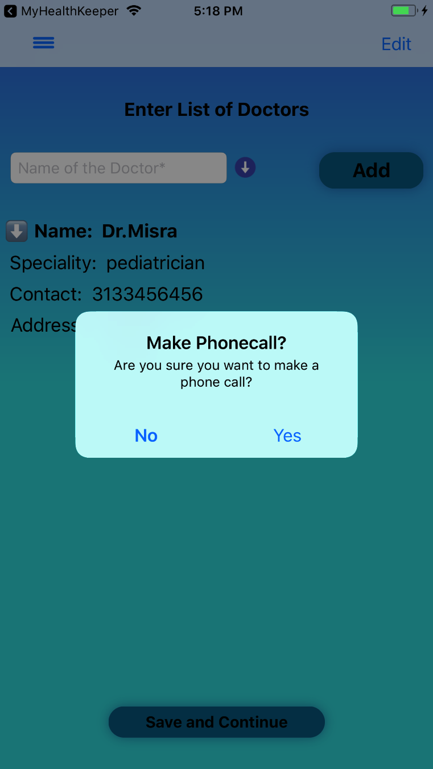 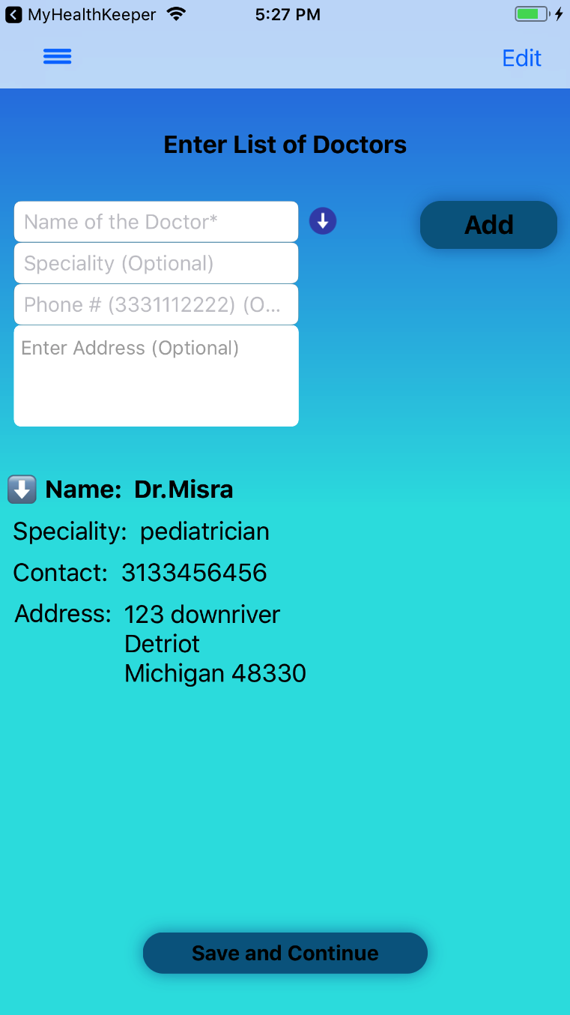

*Figure 57: Make a Phone call Figure 58: Expand Doctor Information*

To make a phone call to the user’s doctor, the user can tap on the Doctor’s Phone Number that was entered in the Doctor Contact field, and an alert will appear asking if the user wants to make a call, see *Figure 57.* To expand the additional information added, the user can tap the drop-down arrows next to the ‘Name’ field, see *Figure 58.*

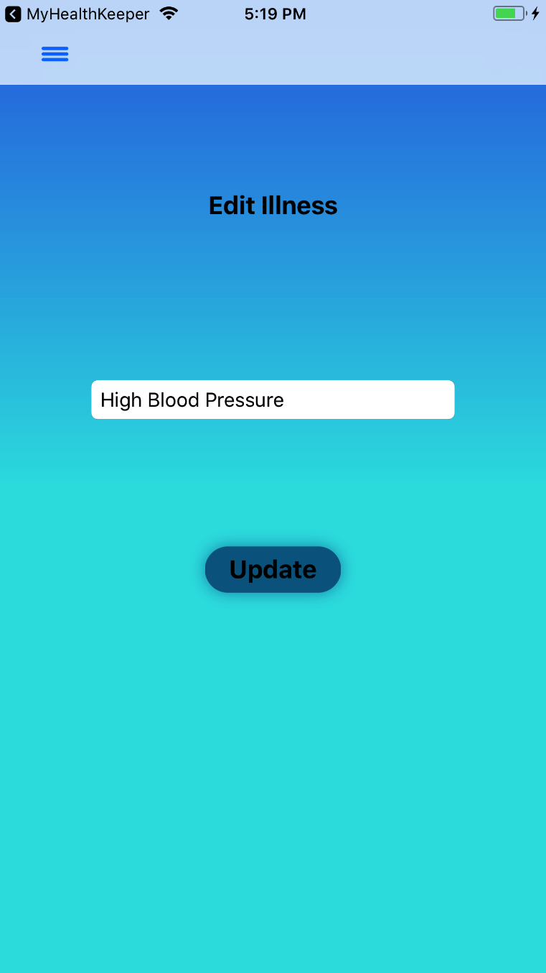 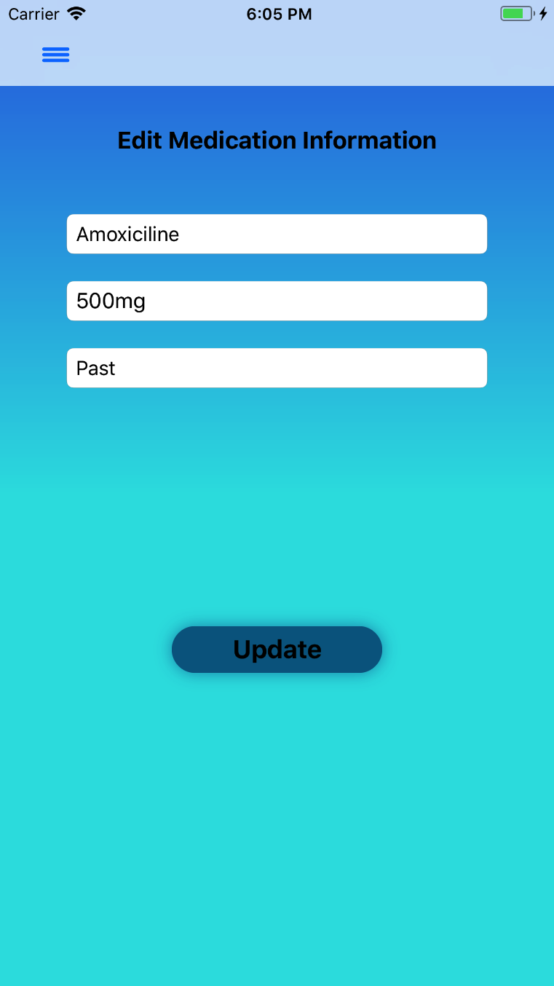

*Figure 59: Edit Illness Figure 60: Edit Medication*

To edit Illness Information, the user can tap ‘Edit’ in the top- right corner, select the information they want to edit, and their data will populate the text fields as shown in *Figure 59.* The user then taps ‘Update’ and will be redirected back to the Enter List of Illness/Disease page with their updated information. To edit Medication Information, the user can tap ‘Edit’ in the top- right corner, select the information they want to edit, and their data will populate the text fields as shown in *Figure 60.* The user then taps ‘Update’ and will be redirected back to the Enter List of Medication page with their updated information.

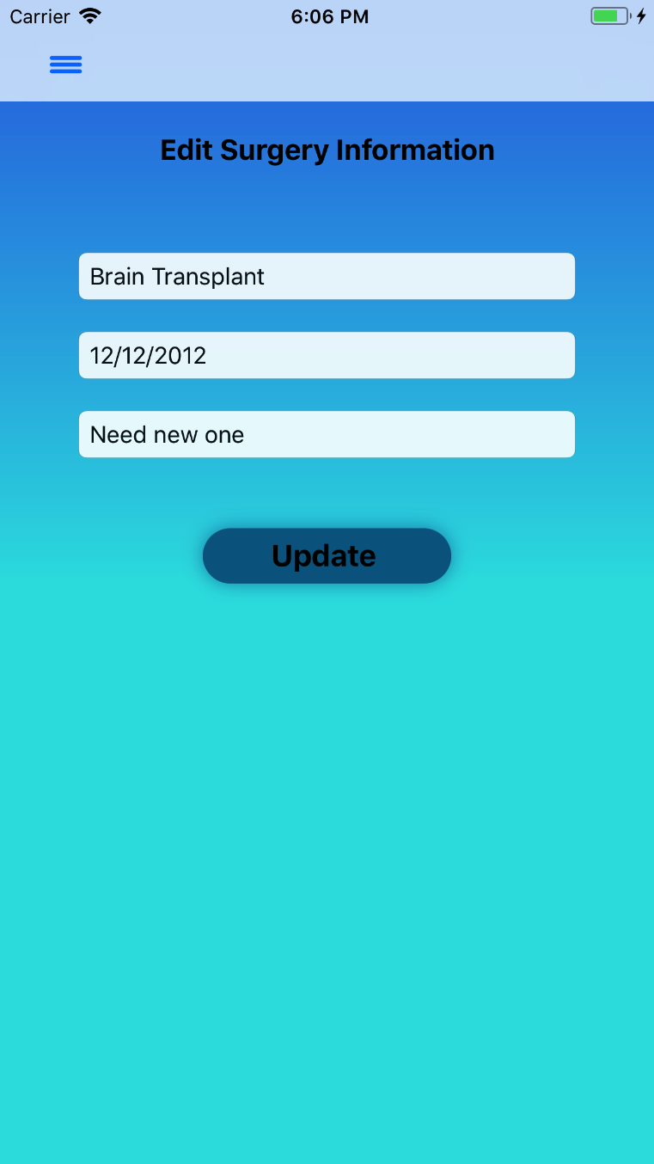 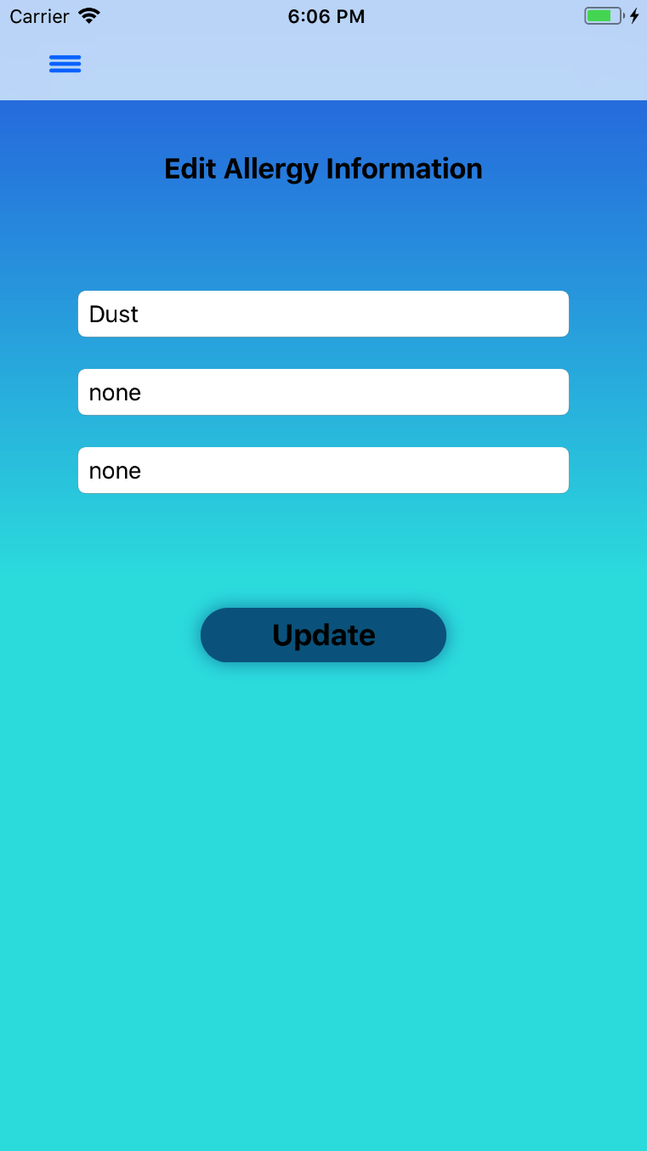

*Figure 61: Edit Surgery Information Figure 62: Edit Allergy Information*

To edit Surgery Information, the user can tap ‘Edit’ in the top- right corner, select the information they want to edit, and their data will populate the text fields as shown in *Figure 61.* The user then taps ‘Update’ and will be redirected back to the Enter List of Surgeries page with their updated information. To edit Allergy Information, the user can tap ‘Edit’ in the top- right corner, select the information they want to edit, and their data will populate the text fields as shown in *Figure 62.* The user then taps ‘Update’ and will be redirected back to the Enter List of Allergies page with their updated information.

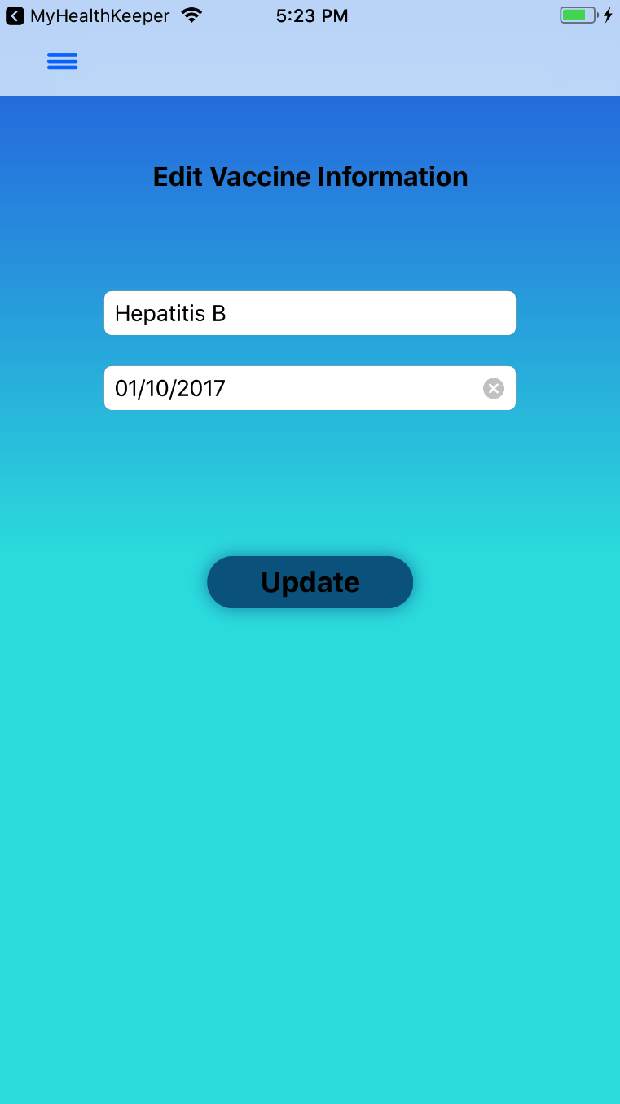 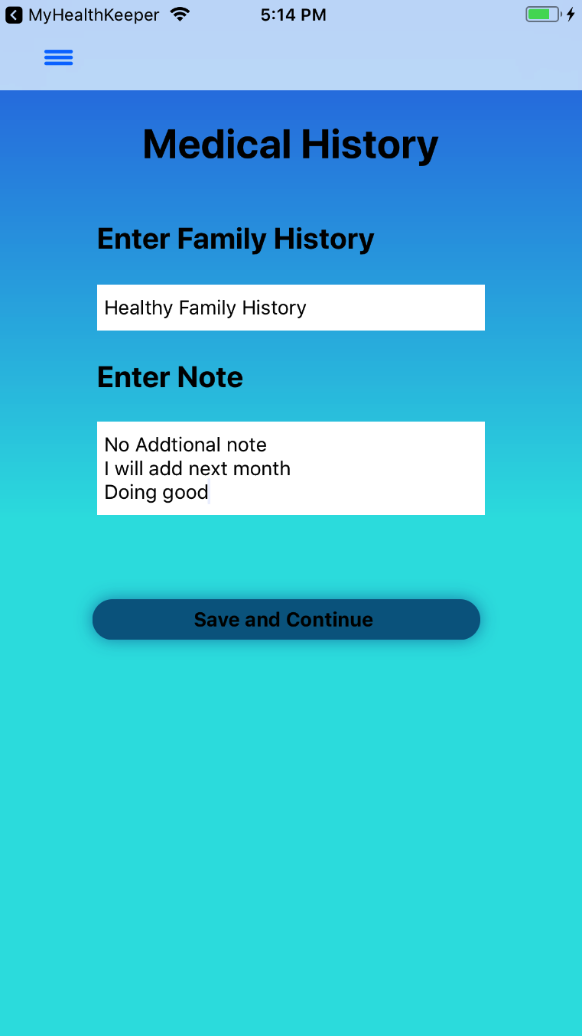

*Figure 63: Edit Vaccine Information Figure 64: Edit Medical History*

To edit Vaccine Information, the user can tap ‘Edit’ in the top- right corner, select the information they want to edit, and their data will populate the text fields as shown in *Figure 63.* The user then taps ‘Update’ and will be redirected back to the Enter List of Vaccines page with their updated information. If the user wants to edit their Medical History, they can navigate to that page (where their current data will populate the text fields), make any necessary changes, and tap on ‘Save and Continue’ as shown in *Figure 64.*

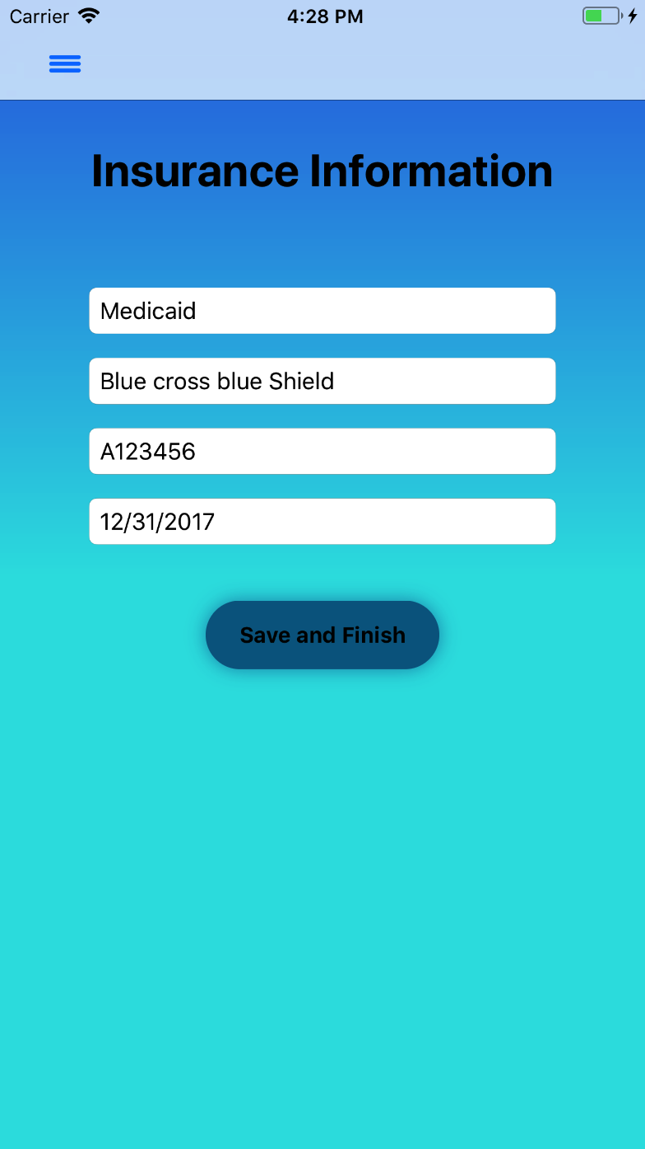 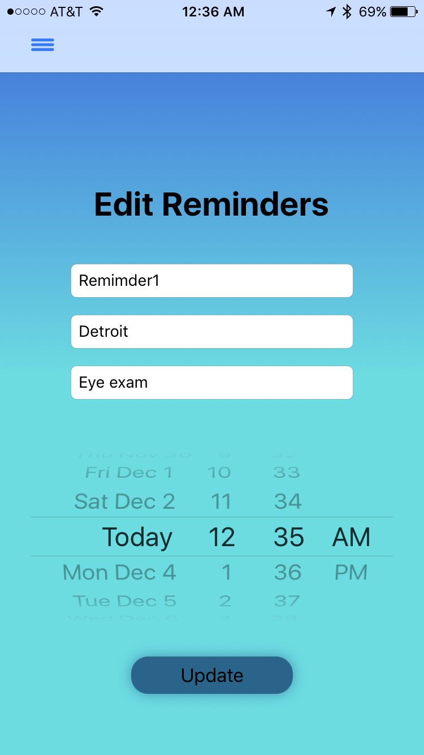

*Figure 65: Edit Insurance Information Figure 66: Edit Reminders*

If the user wants to edit their Insurance Information, they can navigate to that page (where their current data will populate the text fields), make any necessary changes, and tap on ‘Save and Finish’ as shown in *Figure 65.* To edit a Reminder, the user can select the reminder they want to edit in the View Reminders page. If they wish to continue editing their reminder, their data will populate the text fields as shown in *Figure 66.* The user then taps ‘Update’ and will be redirected back to the View Reminders page with their updated information.

# Appendix

## Requirements Traceability Matrix

The following traceability matrix will be used to trace each requirement throughout the iOS application development. Each requirement will have use cases and test cases associated with it.

|  |  |  |  |
| --- | --- | --- | --- |
| **Requirement ID** | **Name** | **Priority** | **Use Case(s)** |
| FR1 | Registration | High | UC-1 |
| FR2 | Setup Security Questions | Medium | UC-2 |
| FR3 | Login to Application | High | UC-3 |
| FR4 | Forgot Password | Medium | UC-4 |
| FR5 | Enter Medical Information | High | UC-5, UC-6, UC-7, UC-8, UC-9, UC-10, UC-11, UC-12, UC-13 |
| FR6 | Update Medical Information | High | UC-21 |
| FR7 | Delete Medical Information | High | UC-15, UC-16, UC-17, UC-18, UC-19, UC-20 |
| FR8 | Upload Photo through Camera | High | UC-22 |
| FR9 | Upload Photo through Photo Library/Gallery | High | UC-23 |
| FR10 | Save Document | High | UC-24 |
| FR11 | View Uploaded Documents | High | UC-25 |
| FR12 | Delete Documents | High | UC-26 |
| FR13 | Add Reminder | Medium | UC-30 |
| FR14 | Monthly Reminder | Medium | UC-27, UC-28, UC-29 |
| FR15 | View Reminder(s) | Medium | UC-31 |
| FR16 | Edit Reminder(s) | Medium | UC-32 |
| FR17 | Delete Reminder(s) | Medium | UC-33 |
| FR18 | View Full Medical History | High | UC-14 |
| FR19 | Export Data to PDF | Low | UC-38 |
| FR20 | Printing Report | Medium | UC-34 |
| FR21 | Connecting iOS Devices | Medium | UC-37 |
| FR22 | Sync Data to/from Server | Medium | UC-36 |
| FR23 | Menu | High | UC-39 |
| FR24 | Logout | High | UC-35 |

|  |  |  |
| --- | --- | --- |
| **Non-Functional Requirements** | **Name** | **Priority** |
| NFR3.3.1.1 | Database Performance | Medium |
| NFR3.3.1.2 | File Upload Time | Medium |
| NFR3.3.2.1 | Database Error Handling | High |
| NFR3.3.3.1 | Offline Application Use Availability | High |
| NFR3.3.3.2 | Online Application Use Availability | Medium |
| NFR3.3.4.1 | Local SQLite Database for Offline Application | High |
| NFR3.3.4.2 | SQLite Data Encryption | High |
| NFR3.3.4.3 | HTTPS for Online Application | Medium |
| NFR3.3.4.4 | User Authentication | High |
| NFR3.3.5.1 | Server Application Maintenance Time | Medium |
| NFR3.3.5.2 | Addition/Updates to Application Features | Medium |
| NFR3.3.6.1 | iOS Compatibility | High |
| NFR3.3.6.2 | Screen Resolution | High |

## Key Terms

|  |  |
| --- | --- |
| **Term** | **Definition** |
| User | An individual interacting with the iOS application |
| HIPAA | Abbreviation for Health Insurance Portability and Accountability Act. Provides data privacy and security for patients’ medical records. |
| Physician | Healthcare professional trained and licensed to practice medicine |
| Pediatrician | Physician who specializes in the medical care of children |
| Patient | An individual who is receiving medical treatment or is under the care of a physician |
| Transition Period | Time period between ages 16 - 25 where patients move from a pediatrician to an adult physician |
| iOS | Operating system developed by Apple used on devices like the iPhone and iPad. |
| EKG | Abbreviation for Electrocardiogram. This medical test records electrical activity of the heart. |
| Chronic Medical Disease | Disease that lasts three months or more. Mostly cannot be cured through medication or prevented through vaccination. |
| GUI | Graphical User Interface allows a user to interact with an electronic device through features like windows, icons, and buttons. |
| Server | To process requests and deliver data to other computers (clients) over a local network or the internet. |
| Bluetooth | A wireless technology to exchange data from mobile phones, computers, and other electronic devices over short distances. |
| FMDB | Abbreviation for Flying Meat Database. It is used as a wrapper for SQLite database. |
| HTTPS | Abbreviation for Hypertext Transfer Protocol Secure. It is secure communication over a network between the iOS application and a server. |
| Objective-C | Objective Oriented Programming Language used by Apple for the OS X and iOS operating systems. |

## References

[1] Apple, “Official Apple Support” support.apple.com/kb/SP751?locale=en_US.

[2] “Amazon DynamoDB: Store and Retrieve Data.” Amazon DynamoDB: Store and Retrieve Data - AWS Mobile SDK, docs.aws.amazon.com/mobile/sdkforios/developerguide/dynamodb-nosql-database-for-ios.html.

[3] “SQLCipher Community Edition.” SQLCipher - Zetetic, [www.zetetic.net/sqlcipher/open-source/](http://www.zetetic.net/sqlcipher/open-source/).

[4] Inc., Apple. “AirPrint for Developers.” AirPrint for Developers - Apple Developer, developer.apple.com/airprint/.